Name: Weekly Homework 4 Due: October 19th
Monday | Work | Tuesday
Solve.  -3x – 8 = 16 |  | Steve is taller than Jon, but Elijah is taller than Steve. Is Elijah taller than Jon?
A bus driver drives 547.25 miles on day 1 of a trip. On day 2, he drives 327.875. How many more miles did he drive the first day than the second day? |  | Simplify  $$-\frac{4}{7}+\left(-\frac{4}{3}\right)=$$
Simplify:  $$-\frac{5}{4}÷2\frac{3}{5}$$ |  | Erase $\frac{3}{5}$ of the shaded part below. How much of the original figure will be shaded?  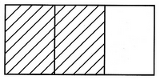
> , <, or =  $$-\frac{31}{8}______-3.92$$ |  | Place the following fractions on the number line.  $$-\frac{5}{3}(a),\frac{18}{11}(b),\frac{10}{4}(c),- \frac{3}{3}(d)$$  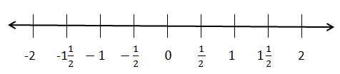
Jon’s car can travel an average of 35 miles per gallon. Write an equation to represent how many gallons he will need for a trip of 656 miles and solve. |  | Solve the equation:  $$2\left(x-4\right)=-22$$
Solve the equation:  $$98=3y-4$$ |  | Convert the decimal 0.23 to a fraction.
Write a simplified expression to represent the perimeter of  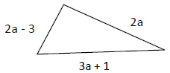 |  | Simplify the following expression:  -7(3e – 2f + 4) + 6e -2
In the problem above, find the value of “a” if you knew the perimeter was 47 meters long. |  | The side of a square is  (4x – 2y). What is the perimeter of the square?
Wednesday | Work | Thursday | Work
What number goes on top?  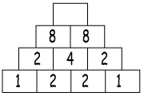 |  | How much change will you get back if you bought three $0.99 chocolate bars and paid with a $5 bill?
Jim had $8.10 when he went to the store. When he got back, he had $3.49. How much did he spend? |  | What is the distance from point A to point D on the number line?  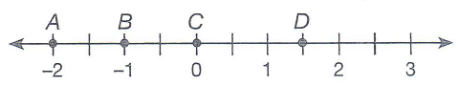
Solve.  -4 + 8 – (-3) =  5 + (-6) – 12 = |  | Expand the following:  $$\frac{2}{3}(12x-9)$$
Write the fraction $\frac{17}{7}$ as a repeating decimal. |  | Write the following rational numbers in increasing order.  $$-\frac{2}{5},- 7, \frac{3}{9}, \frac{11}{12}$$
Ed earns about $8 per hour helping out neighbors. Write an equation to show how many hours she needs to work and earn $86. |  | Solve the equation:  $$10=-4+x$$
Which property is demonstrated by the following statement?  16 + (22 + a) = (16 + 22) +a |  | Expand the following:  $$\frac{3}{8}(16x-24)$$
Write an expression to represent the perimeter of 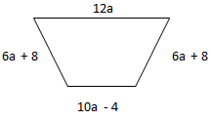 |  | Find the sum of (x + 5) and (2x + 3)
In the problem above, find the value of “a” if you knew the perimeter was 250 inches long. |  | Simplifying the following expression:  -3(4x – 5y + 6) + 8x – 9

