Name ____________________________________ Cells Notes
Organelle: An organelle is a part of a ___________ that has a specific ______________ within the cell to help the cell meet its overall needs

Organelle | Where Found  (plant, animal, both) | Function (job in the cell) | Location on the cell | Shape/drawing OR Additional information
Nucleus
Cell Wall
Cell Membrane
Cytoplasm

Label the following cell parts on each of the plant and animal cells: Nucleus, Cell Wall, Cell Membrane, Cytoplasm, and Golgi Body.
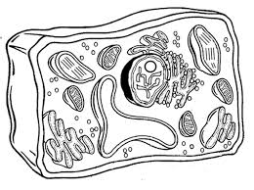
_________ Cell:

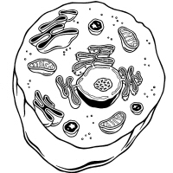
_________ Cell:

Cellular Transportation
- Cells get the ___________ they need through cellular ___________.
- Cells need to take in _________ and get rid of ___________.
- They also need to take in and send out other _________________.
- Cell membranes are ________________ _________________ which means they allow only certain things to pass through.

PASSIVE TRANSPORT
Movement of materials across
ACTIVE TRANSPORT
The movement of materials through
DIFFUSION
When molecules move
OSMOSIS
The diffusion of
FACILITATED DIFFUSION
Diffusion of glucose molecules
ENDOCYTOSIS
When a cell takes

EXOCYTOSIS
When vesicles (cell membrane)
Moving Cellular Material

Identify and Label the different types of cellular transportation.

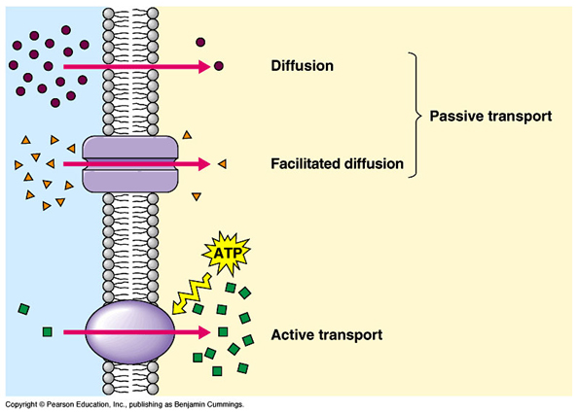

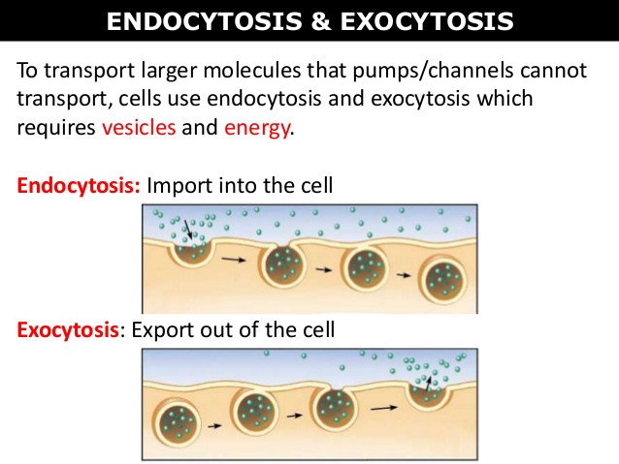

Equilibrium- When the amount of material is __________ on either side of the ______ _________________ and there is no net movement.
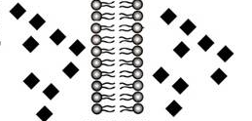

Organelle | Where Found  (plant, animal, both) | Function (job in the cell) | Location on the cell | Shape/drawing OR Additional information
Chloroplasts
Mitochondria
Vacuole

Go back to the first page and label the following: Chloroplast, Mitochondria, and Vacuole.

Process | Definition or what is happening inside the cell | Where does it occur (what organelles are involved?) | Additional information
Photosynthesis

Respiration

Fermentation

The chemical equation for photosynthesis: 6 CO₂ + 6 H₂O → C₆H₁₂O₆ + 6 O₂
The chemical equation for respiration: C₆H₁₂O₆ + 6O₂ --> 6CO₂ + 6H₂O + energy

Discussion: What is the difference between breathing and respiration?

Nucleus- Contains the _______________________________ or DNA.
New cells are made through two different processes; mitosis and meiosis.
Mitosis:_________________________________________________________________________________________________________________________
Somatic:_________________________________________________________
Daughter Cell: ____________________________________________________
________________________________________________________________

Diploid:_________________________________________________________________________________________________________________________

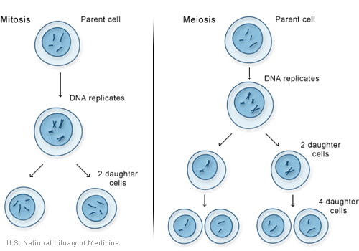
Meiosis:_______________________________________________________________________________________
__________________________________
Sex Cell:_________________________________________________________
______________________________
__________________________________
Haploid:_______________________________________________________________________________________
__________________________________

