- After paying their monthly expenses, the two owners of a shop have pdollars of profit. They put of the money in the bank and spend of it on advertising. The two owners will share the remaining money equally as a bonus. Which expression represents the bonus, in dollars, that each person will receive?
A)
B)
C)
D)

Commentary:
In this item, students are asked to determine which expression represents the bonus, in dollars, that each owner receives using conceptual understanding of the four operations.
The correct answer choice is A.
Answer choice B is incorrect because 3/10 p represents a student mistakenly adding 1/3 p + ½ p for a sum of 1/5, then subtracting 1/5 p from ½ p. Answer choice C is incorrect because 1/3 p represents only the amount the owners spent on advertising or the student may have divided the remaining 1/6 p by ½ instead of by 2. Answer choice D is incorrect because 5/6p represents the sum of the amount of the profit the owners put in the bank and spent on advertising.
2. Point P is located on a number line at The location of point Q is shown on the number line with point P .
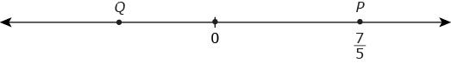
The sum of a number k and is represented by point Q . Which fraction is one possible value of k ?
A)
B)
C)
D)
3. A recipe calls for 4 eggs, but Mara only has 3. She decides to adjust the amounts of the other ingredients proportionally. The original recipe calls for cups of sugar. Which expression represents the amount of sugar, in cups, Mara should use?
A)
B)
C)
D)

Commentary:
In this item, students are asked to determine which expression represents the amount of sugar Mara should use to adjust a recipe.
The correct answer choice is C.
Answer choice A is incorrect because 3/2 x ¼ only represents the amount of sugar needed if Mara used only 1 egg. Answer choices B and D are incorrect because both of these choices are using division instead of multiplication.

4. Researchers randomly selected 10 males and 10 females from a study involving a new medication to determine if the medication affected weight. The number of pounds gained (positive numbers) and the number of pounds lost (negative numbers) for the two groups were recorded in the table and plotted on the line plot.
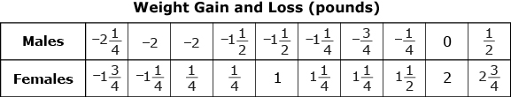

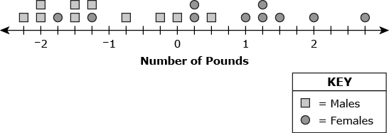
Part A
What is the difference between the minimum value and the maximum value of the weights for both the male group and the female group? Show your work and label your answers.
Part B
Estimate the center of the data for males. Explain your answer.
Part C
Estimate the center of the data for females. Explain your answer.
Part D
Did the medication seem to affect each group the same or not? Give an explanation to justify your answer.
5. Ashley has to read a book that is p pages long. On Monday, she read of the pages in the book. On Tuesday, she read of the remaining pages in the book.
Part A
In terms of p , what portion of all the pages in the book did Ashley read on Monday and Tuesday combined? Show your work or explain your answer.
Part B
On which day did she read more pages? Explain your answer.
Part C
The book has less than 240 pages. Write an inequality that can be used to determine how many pages are left for Ashley to finish reading the book. Solve your inequality and explain what your solution means.

6. In the diagram below, points A , B, and D are on the same line, and the measures, in degrees, of and are labeled in terms of x .
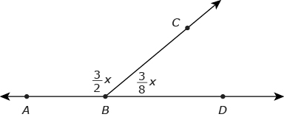
Part A
Write an expression in terms of x that represents the degree measure of an angle that is the measure of Show your work.
Part B
Write an expression in terms of x that represents the degree measure of an angle that is complementary to Explain your answer.
Part C
Using the fact that and are supplementary, write an equation that can be used to solve for x .
Find the value of x by solving the equation you wrote. Show your work.

7. Three pizzas of the same size were purchased for a party. After the guests finished eating pizza, of the first, of the second, and of the third pizzas were leftover.
Part A
If the leftover pieces are combined, what fraction of one whole pizza remains? Explain how you got your answer.
Part B
What fraction of all three of the pizzas purchased for the party was eaten? Explain how you got your answer.
Part C
Only six guests ate pizza at the party. If all of them ate the same amount, what fraction of one pizza did each person eat? Explain how you got your answer.
8. Two consecutive numbers add up to 127. What are the two numbers?
A) 62 and 63
B) 63 and 64
C) 64 and 65
D) 45 and 82
9. Jill spent a total of $5.37 at the fair buying three hotdogs and one hamburger. A hamburger cost $0.37 more than a hotdog. How much does a hotdog cost?
A) $0.88
B) $1.25
C) $1.62
D) $5.00
10.
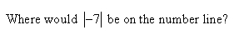
A) 7 units to the right of zero.
B) 7 units to the left of zero
C) 7 units to the left and right of zero
D) 7 units from zero

11. A fruit delivery truck traveled 65 miles for Monday deliveries. The truck starts and the fruit distribution center, makes 3 deliveries, and returns to the fruit distribution center. The 4 distances traveled are consecutive numbers that differ by half a mile. How far is it from the fruit distribution center to his first delivery?
A) 15.5 miles
B) 16 miles
C) 16.5 miles
D) 17 miles

12. Complete the task in each part.
Part A
Evaluate the expression 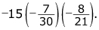
Write your answer as an integer, fraction, or mixed number in simplest terms. Show your work.
Part B
Evaluate the expression 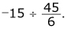
Write your answer as an integer, fraction, or mixed number in simplest terms. Show your work.
Part C
Place a second set of parentheses in the expression so that the value of the expression is Show your work.
Explain how the parentheses changed the order of operations in the original expression.
13. A teacher writes two equations as shown.
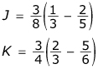
Part A
Solve both equations. Express your answer as a fraction in simplest form. Show your work.
Part B
What is the sum of J and K? Express your answer as a fraction in simplest form. Show your work.
Part C
What fraction when added to the result of Part B would equal zero? Explain your answer.
Part D
Create a real-world situation to represent the description in Part C.
14. Ions are atoms or groups of atoms with positive or negative electrical charges. The charges of two ions are shown in the table. Use the charges to answer the questions below.
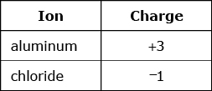
Part A
One aluminum ion and one chloride ion are combined. What is the total charge? Explain your answer using a number line.
Part B
A different atom is formed by combining 2 aluminum ions and 9 chloride ions. What is the total charge? Show your work.
Part C
What ion or combination of ions from the table can be added to the atom formed in Part B to give a total charge of 0? Justify your answer.
15. Point Mis located at and point Pis located at on a number line.
- is called the coordinate of M.
- is called the coordinate of P.
Part A
Plot and label points M and P on a number line.
Part B
What is the distance between points M and P ? Show your work.
Part C
Point X is the same distance from point P as point M , but it is not the same point. What is the coordinate of point X ? Explain your answer.
Part D
What is the distance between points X and M ? Explain your answer.
16. Evelyn is working with the following expressions.
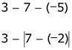
Part A
Show the expression on a number line. Explain how you could use the number line to arrive at the value of the expression.
Part B
Find the distance between 3 and using absolute value. Show your work.
Part C
What is the value of Show your work.
Part D
Evelyn said that if she rewrites the expression as the value would be She made at least one error. Explain the error(s) that Evelyn made.
17. The dimensions of a rectangular picture are inches by 11 inches. The picture is scaled down in size so that its width and length are each of the original size.
Part A
What are the dimensions, in inches, of the smaller picture? Show your work.
Part B
What is the area, in square inches, of the smaller picture? Show your work.
Part C
What percent of the area of the original picture is the area of the smaller picture? Show your work or explain your answer.
18. What is the multiplicative inverse of 1?
A)
B)
C) 1
D) 1
19. At the fall festival the tennis team is selling hamburgers for $2.00, hotdogs for $1.50 and drinks for $1.00. Half of the money raised will go towards the purchase of team uniforms. If they sell 21 hamburgers, 34 hotdogs, and 65 drinks, how much money will they have to put towards the purchase of uniforms?
A) $60
B) $79
C) $120
D) $158
20. In January Mary starts off with $50 in her checking account. During the month she deposits $235.89 and writes checks totaling $45.77. At the end of the month she decides to take half of the money left in the account and deposit it into her savings account. How much did she deposit in her savings account?
A) $142.94
B) $165.83
C) $120.06
D) $240.12
21. Multiply.
-10 × -33
A) -330
B) -33
C) 33
D) 330
22. If the perimeter of a triangle measures 42 feet and the three sides are consecutive numbers, what are the side lengths?
A) 11, 12, and 13
B) 12, 13, and 14
C) 13, 14, and 15
D) 14, 15, and 16
23. Simplify.
-1.6 + 5.7 + -3.2
A) 0.8
B) 0.9
C) 1
D) 1.1
24. What is the value of
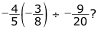
A)
B) 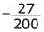
C) 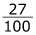
D)
25. Let and 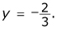The variable z has an unknown value.
Part A
What is the product of x and y? Show your work, and explain why the product is negative or positive.
Part B
Let v be the result of dividing x by z. Explain any requirements there are for the value of z, if v is a rational number. Explain your reasoning.
Part C
Is the quotient of w divided by x a rational number? Explain your answer.
26. A telephone survey asked 240 people to rate their telephone service. The results are shown in the graph.
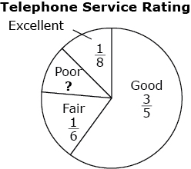
Part A
Express the fraction of people who answered “excellent” as a decimal. Show your work.
Part B
How many people in the survey rated their telephone service “good”? Show your work.
Part C
If one-third of the people who answered “fair” had cell phones, what fraction of the total does this group with cell phones represent? Show your work.
Part D
What fraction of the people surveyed answered “poor”? Explain your answer.
27. A teacher writes two equations as shown.
Part A
Solve both equations. Express your answer as a fraction in simplest form. Show your work.
Part B
What is the sum of J and K? Express your answer as a fraction in simplest form. Show your work.
Part C
What fraction when added to the result of Part B would equal zero? Explain your answer.
Part D
Create a real-world situation to represent the description in Part C.

28. Each section of a sidewalk is 2 feet long and 1.5 feet (ft) wide. Three sections are damaged, and the homeowner plans to cut out a rectangle 26 inches by 4 inches (in.) to replace the damaged area. The diagram below is shaded to show the damaged area.
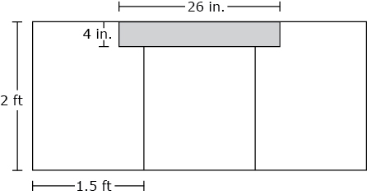
Part A
What are the dimensions, in square feet, for the rectangular area that will be replaced? Show your work or explain your answer.
Part B
Use the dimensions from Part A to determine the area in square feet. Write your answer as a decimal that describes the exact area. Show your work.
Part C
The amount of time needed for the concrete to dry is estimated as 2 hours per square foot. At that rate, how many minutes will it take for the replaced area to dry? Explain how you got your answer.
Part D
What fraction of the total area of the three slabs will be replaced? Explain your answer and give your final answer in fraction form.
29. Ralph simplified the expression
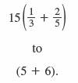
Which of the following properties of the real numbers did Ralph use?
A) associative property of multiplication
B) commutative property of multiplication
C) distributive property
D) multiplicative identity property
30. Mr. Nash is teaching his students about operations with fractions and decimals with negative and positive signs. He writes the following expression.
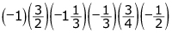
Part A
What is the value of the expression? Show your work.
Part B
Mr. Nash removes 3 factors from the expression. The value of the new expression is 1. Which 3 factors did Mr. Nash remove? Show your work.
Part C
Convert the following fractions to decimals. Show your work.
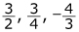

31. Which expression represents a situation where the product is less than each of its factors?
A) 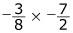
B) 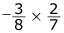
C) 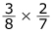
D) 