Unit 2 Study Guide Name_____________________________

- In each expression below, identify the coefficient, constant, and variable.
- 7x + 9
- 6y – 5
- 4.5 – 2.7z
- –9w – 22
- Create a like term for the given term.
- 4x
- 13y
- 15x²
- 16xy
- X
- Use the Distributive Property to rewrite the expressions without parentheses
- 5(x + 4)
- 7(x – 12)
- 3(x - 14)
- -1(x – 2)
- (x - 2)5
- ⅔(6x + 12)
- 2.5(3x – 4.1)

- Simplify the algebraic expression if possible.

- 7y + 8x + 3y + 2x + 9
- 17x + 18x + 3
- 7y + 8x + 3y + 2x
- 5x +2(x + 8)
- 12(x +4) – (9x + 3)

- Write each phrase/sentence given below as a mathematical expression
- The total amount of money that your mother distributes to you and your 4 siblings, if she gives each person x dollars.
- Your age if you are x years older than your 8 year old brother.
- How many bananas each person gets if starting with 11 bananas, 1 is eaten, and the rest are divided equally among five friends.
- The length of a rectangle is six inches longer than its width. The width is w inches.
- A dog weighs four pounds more than triple the weight of a cat, whose weight is c pounds

- Whose method of solving the equation is better? Explain your answer.
Michael Amanda
$x+18=29$ $x+18=29$
$-18 -18$ $-29 -29$
$x=11$ $x-11=0$
$+11+11$
$x=11$
- 7x – 2 = 26
- -6h – 6 = 30
- 5x + 20 = -20
- -24 = 14y – 5
- -4.5x + 12.3 = -23.7
- $\frac{x}{3}-14=-8$
- $2\left(m-8\right)=12$
- Write an equation then solve.
- You sell brownies for $3 each. You sold 12 more this week than last. Altogether, you made $84. How many brownies did you sell each week?
- Find the length of a rectangle if its width is 13 less than the length and its perimeter is 90 cm.
- Six times the difference of a number and 9 is 19 less than the number.
- Jose went to an all-you-can-eat buffet. He paid $15 for his meal and $2 for each soda. If Jose spent $21, how many sodas did he buy?

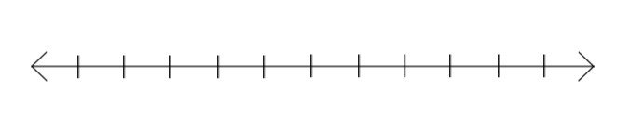
- Write an inequality for each sentence below, and then graph the solutions of each inequality on a number line.
  - y is less than 8.

  - f is greater than -5.
  - j is greater than or equal to 4.

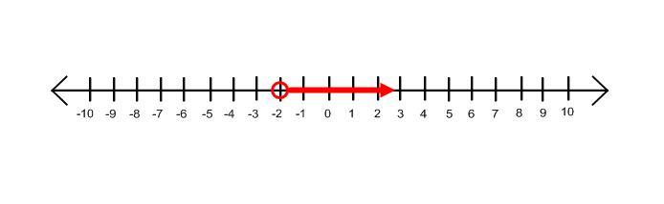
- Write an inequality for the graph below.

- Write an inequality for the graph below.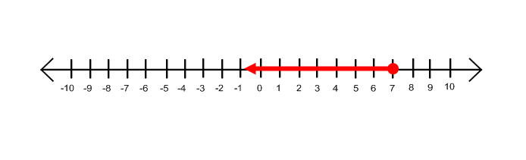
- Write an inequality for the graph below.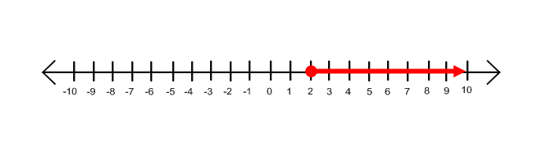
- Write an inequality for each sentence below, and then graph the solutions of each inequality on a number line.
- w is greater than 7.

- p is less than or equal to -1.

- Solve, check and graph the following inequalities.
- x + 7 > -2
- x + 3 < -3
- -8 < x + 15
- x – 4 ≤ 1
- x – 1 > 6

- Suppose you must maintain at least $500 in your checking account in order to have free checking. Your balance is $612 and then you make a deposit of $79. How much can you withdraw and still keep your free checking? Write an inequality and solve.

- You need no more than 2,200 calories in a day. You had 720 calories at breakfast and plan on having 1,000 calories at dinner. How many calories, c can you eat for lunch? Write an inequality and solve.

- Solve, check and graph the following inequalities.
- 5x > -25
- -7x ≤ -21
- 18 > 2x
- 25x ≥ 100
- -30 ≤ -6x

- Solve, check and graph the following inequalities.
- $\frac{x}{5}$ ≥ 2
- $\frac{x}{2}$ < 14
- -3 ≤ $\frac{x}{-6}$
- $\frac{x}{-9}$ > 1
- $\frac{x}{-4}$ ≥ -3

- What happens to the inequality symbol when you do each of the following to both sides of an inequality?
- Multiply by a positive number
- Divide by a positive number
- Add a negative number
- Subtract a negative number
- Divide by a negative number
- Multiply by a negative number

- 2x – 8 ≥ 10
- 3 – 2x ≤ -9
- $\frac{x}{5}+5 <10$
- $\frac{x}{-3}+4 ≥6$
- $-4\left(x-7\right)≥12$

- Dale has $25 to spend at a carnival. If the admission to the carnival is $4 and each ride costs $1.50 each, what is the greatest number of carnival rides Dale can go on?
Part A
Define the variable

Part B
Write the Inequality and solve

Part C
Graph your solution on a number line

Part D
Interpret your solution by explaining what it means

