Name _________________________________ Microscope Lab Activity
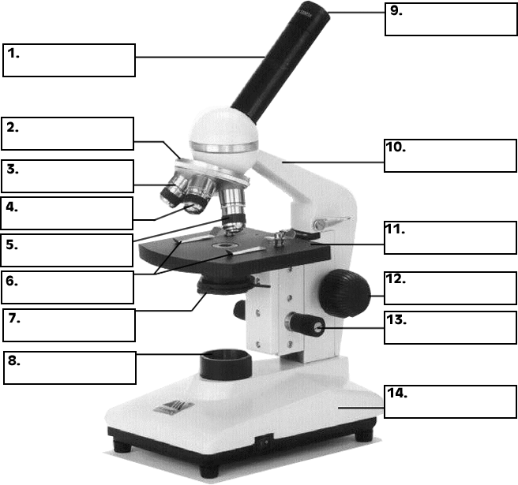
Answer the following questions as we go through the microscope power point:

- What is the proper way to carry a microscope?
- What is the purpose of the objectives?
- What is the diaphragm on the microscope used for?
- What is the difference between the fine and coarse adjustments?
- What part of the microscope produces the light?
- What is the total magnification power of your microscope under the following operating conditions?
OBJECTIVE OCULAR TOTAL MAGNIFICATION (X)
DIN 4 10 x _______________
DIN 10 10 x _______________
DIN 40 10 x _______________
- What happens to the light intensity as you adjust the diaphragm? Explain your answer.

- Explain why a specimen that you wish to view with a compound light microscope must be very THIN.

- What happens to the SIZE of the field of view of a microscope when you switch from low power to high power? (Does the field of view – the amount of the object you can see – become larger of smaller?

- In what position should the stage be located when you first begin to focus in on an object? Why would you put it in this position?

- Compare the POSITION of the letter “e” as seen with the microscope to the POSITION of the letter “e” on the slide, how has it changed? If it is right side up and forward on the slide, how is it seen through the microscope? Draw what you see in the microscope field of view in the circle:

- When you move the slide to the left on the stage, in what direction does the image appear to move?

- When you move the slide away from you on the stage, in what direction does the image appear to move?

- View the “e” slide using all 3 objectives. Identify the magnification and draw what you are able to see in the field of view:

MAG _________ MAG __________ MAG ________
Onion Cell Lab

Introduction:
Many things that are viewed using a microscope, particularly cells, can appear quite transparent under the microscope. The internal parts of the cells, the organelles, are so transparent that they are often difficult to see. Biologists have developed a number of stains that help them see the cells and their organelles by adding color to their transparent parts. Today we will be using methylene blue.

Materials:
· Onion cells (fresh and prepared)
· Stain (methylene blue)
· Paper towel

· Microscope
· Eyedropper
· 2 flat slides
· 2 cover slips
Procedures:
1. Get a glass slide and cover slip for yourself and make sure they are both thoroughly clean.

2. Using one of the cut sections of onions at your station, remove the single layer of epidermal cells from the inner (concave) side of the scale leaf (The thinner the better).

3. Place the single layer of onion on a glass slide. Make sure that you do not fold it over or wrinkle it.

4. Place a drop of iodine stain on your onion tissue.

5. Put the cover slip on the stained tissue and gently tap out any air bubbles.

6. Observe the cells under 4x, 10x, and 40x. Sketch what you see in the circles below:

MAG _________ MAG _________ MAG ________

Observing Mitosis Lab
Background: In a growing plant root, the cells at the tip of the root are constantly dividing to allow the root to grow. Because each cell divides independently of the others, a root tip contains cells at different stages of the cell cycle. This makes a root tip an excellent tissue to study the stages of cell division.

Procedure:
1. Obtain your microscope. Make sure that the low power objective is in position and that the diaphragm is open to the widest setting.

2. Obtain a prepared slide of an onion root tip. Hold the slide up to the light to see the pointed ends of the root sections. This is the root tip where the cells were actively dividing

3. Place the slide on the microscope stage with the root tips pointing away from you. Using the low-power objective to find a root tip, and focus it with the coarse adjust until it is clearly visible. Just above the root “cap” is a region that contains many new small cells. The larger cells of this region were in the process of dividing when the slide was made. These are the cells that you will be observing. Center the image, then switch to high power.

4. Observe the box-like cells that are arranged in rows. The chromosomes of the cells have been stained to make them easily visible. Select one cell whose chromosomes are clearly visible. (If you need to change the focus when using high power, remember to only use the fine adjust!)

5. Sketch the cell that you selected in the circle on the right.

___________
6. Look around at the cells again. Select four other cells whose internal appearances are different from each other and the first one that you sketched. Sketch them in the circles below. Using the cards, identify what stage of division the cells are in and write it on the line below the circle.

__________ ___________ ___________ ___________
