Name __________________________________________________________ Body Systems Notes

Nervous System
Function  - Controls all of the body’s ________________________  - Senses and recognizes information from ___________________ and outside of the ___________ | Main parts (and organs)  - ________________  - Nerves  - _______________ cord | What does it help you do?  - Move  - Sense things from the ___________________________ | 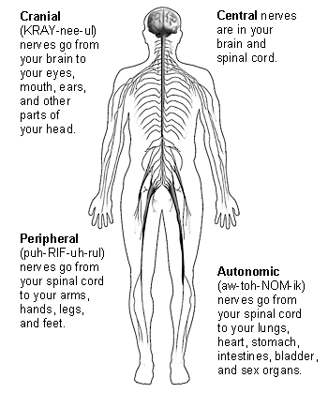  Picture of the system
Interactions with other systems

Integumentary (Skin) System
Function  - 1st line of _________________ against disease  - Helps maintain body _____________________  - Keeps ____________ inside | Main parts (and organs)  - Skin  - ___________ ______________  - Hair  - _______________ | What does it help you do?  - Helps you maintain ___________ (don’t dehydrate)  - Helps you know your __________________ by feeling things around you  - Protect _______________  - Remove ________________ | Picture of the system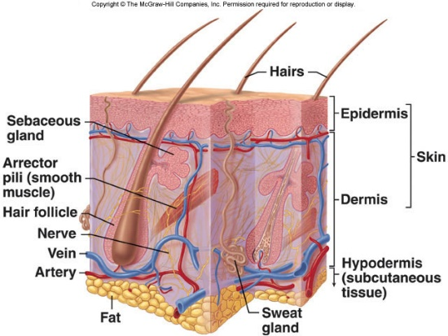 | Interactions with other systems
Skeletal System
Function  - Support and ____________________ body parts.  - Helps maintain ______________________  - Makes red _______________ cells (red bone marrow) | Main parts (and organs)  - Bones  - ______________________  - Connective _____________________ | What does it help you do?  - Helps __________________ your body parts  - Helps support your body during _________________  - Helps protect major organs: ______ helps protect brain; Sternum and ribs helps protect ________ and lungs, and the vertebrae help protect the ______________. | Picture of the system  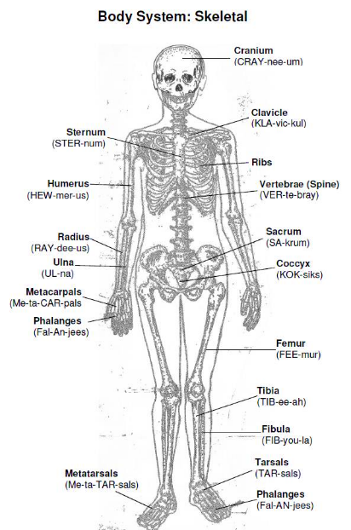 | Interactions with other systems

Muscular System
Function  - Helps you _________________.  - Moves ________________________ through the body  Main parts (and organs)  - _____________________  - Tendons  - Ligaments  - Muscles inside _______________________ | - Types of Movement  - ______________- under conscious control  - ______________- not under conscious control  - Three types found in the body:  - Cardiac (_____________) – found in the ____________  - ____________ (Voluntary) - attaches to the bones  - Smooth (____________) – lines ____________ and vessels. | What does it help you do?  - Helps you ____________  - Helps you move materials through the ___________  - Maintain ______________________  - Skeletal muscles work in pairs: one ____________ and the other returns to its original _______________. | Picture of the system  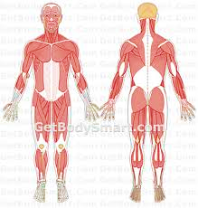
Interactions with other systems

Circulatory (or Cardiovascular) System
Function  - Carries ______________ and oxygen to the ____________ of the body  - Carries waste away from the ____________, such as carbon _________________. | Main parts (and organs)  - Heart  - _______________________  (made up of plasma, red blood cells, white blood cells & platelets)  - Veins  - _______________________ | What does it help you do?  - Arteries help carry oxygenated blood ______________ from the heart  - ________________ carry un-oxygenated blood toward the heart  - ____________________ are tiny blood vessels that connect _________________ and veins. _______ exchange takes place here. | Picture of the system  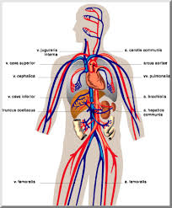 | Interactions with other systems

Respiratory System
Function  - Puts _________________ into the body & removes ________________ dioxide | Main parts (and organs)  - Lungs  - Nasal ___________________  - Throat  - __________________ | What does it help you do?  - ___________________________  - Sustain Life | Picture of the system  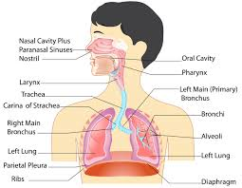
Interactions with other systems

Digestive System
Function  - Takes ________________ & breaks it down into ___________________ the body needs | Main parts (and organs)  - ________________  - Esophagus  - Stomach  - ____________________  - Pancreas  - _____________________  - Large intestines  - Rectum  * Numbers Show the Path of Food | What does it help you do?  - It provides nutrients to your body’s __________ | Picture of the system  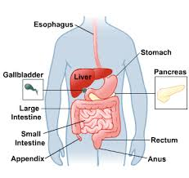
Interactions with other systems

Excretory System
Function  - Removes _________________ from blood  - Removes harmful substances from ________________  - Regulates ___________ fluids | Main parts (and organs)  - ___________________  - Urinary Bladder | What does it help you do?  - ___________________________ homeostasis  - Remove _________________ | 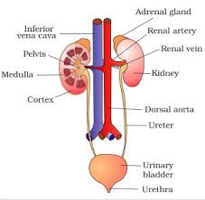  Picture of the system
Interactions with other systems
Immune System
Function  - Fights off _________________________ | Main parts (and organs)  - ________________ nodes  - ____________ blood cells  - Skin | What does it help you do?  - Helps maintain a ____________________ body | Picture of the system  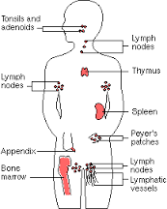
Interactions with other systems

Reproductive System
Function  - Produce _____________.  Male-  Produce ___________  Female-  Produce ___________ | Main parts (and organs)  Male  - __________  - __________  Female  - __________  - __________  - __________ | What does it help you do?  - Continuation of the __________. | Picture of the system  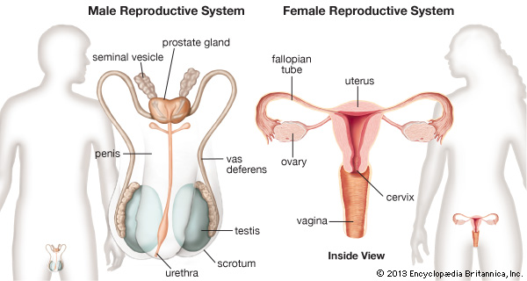

NERVOUS SYSTEM
- Provide an example of a reflex. _____________________________________________________________________________
- Your spinal cord is made up of: a) Bone b) Muscle c) Nerve cells d) Tendons
- Your brain and spinal cord make up your ____________ nervous system.
EXCRETORY SYSTEM
- Your excretory system removes wastes from the __________ and regulates the body’s fluids.
- What does the bladder store? _________________________
CIRCULATORY SYSTEM
- What type of tissue in the heart pumps blood throughout the body? _______________________
- Blood is made up of different types of cells so it is a ______________________________.
- What would happen if your circulatory system did not deliver oxygen to your cells? _____________________________________________
- If you wanted to see red blood cells being created, where would you look? _______________________
- How do white blood cells compare to red blood cells? ____________________________________________________________________
- Which blood vessel allows for the exchange of gases between the blood and body cells? _____________
RESPIRATORY SYSTEM
- What happens when your diaphragm relaxes and moves upward? _______________________________
- Where does the transfer of oxygen into the bloodstream take place? _____________________________
IMMUNE SYSTEM
1. Cells that respond to pathogens or disease-causing agents are called ________________.
2. When your own immune system is working to destroy a pathogen this is called ___________ immunity.
3. When a baby “borrows” antibodies from its mother by drinking milk, this is known as _____________ immunity.
4. The mucus in your nose and the acid in your stomach are both defenses against pathogens. Which system is also a first-line defense? _________ DIGESTIVE SYSTEM
- Where does digestion begin? ______________
- Chewing is an example of what kind of digestion? ______________________________
- What is the path of food through the digestive system? _____________________________________________________________________
- What is the main function of the villi in the small intestine?__________________________________________________________________
SKELETAL SYSTEM
- What is the main function of bone marrow? ________________________________
- The backbone is made up of little ring-shaped bones called ___________________. Their job is to protect our ________________________.
MUSCULAR SYSTEM
- Muscles cause bones to move when they __________ on bones.
- _________________ muscle is found in the digestive tract and in blood vessels.
- True/False. Muscles work in pairs. ______________
- __________________ muscle is found only in the heart.
- Where might you find involuntary muscle? __________________________
- The two ways that muscles move is by _____________________________________________
- Glucose supplies your muscles with: a) Oxygen b) energy c) water d) blood

