Name: _____________________________________ Body Systems Study Guide
- List from simplest to most complex the levels of cellular organization, explain and give an example of each level.
______________________________________________________________________________________________________________________________________________________________________________________________________________________________________________________________________________________________________
- Define homeostasis and explain why it is important to the human body.
____________________________________________________________________________________________________________________________________________________________________________________________________
- To bend a joint, one muscle _____________ while another muscle returns to its original length.
- What is produced in the bone marrow? This is an example of the interaction of which systems?
__________________________________________________________________________________________________
- Describe and Explain the function of each of the following parts of the circulatory system: Heart, Blood, Blood Vessels. _____________________________________________________________________________________
____________________________________________________________________________________________________________________________________________________________________________________________________
- What is the body’s first line of defense against pathogens? ___________________________________________
- Water from the digestive system is absorbed in the ______________ intestine.
- Nutrients from the digestive system are absorbed in the ______________ intestine.
- In gas exchange, _____________ passes from the alveoli into the blood.
- There are three types of muscles found in your body. Name each type, describe the muscle movement (voluntary/involuntary), tell where it is found and its function.
______________________________________________________________________________________________________________________________________________________________________________________________________________________________________________________________________________________________________
- What are the two types of immunity and how do they compare?
__________________________________________________________________________________________________
- The nervous system is divided up into the central nervous system (CNS) and the peripheral nervous system (PNS). Explain how these two systems work together and the parts that make up each system.
____________________________________________________________________________________________________________________________________________________________________________________________________
- List the organs of the human body that are involved in excretion. ______________________________________
- The respiratory system brings _______________ into the body and releases __________________ back into the environment.
- What are the bones called that make up the backbone and what do they protect?
___________________________________________________________________________________________
- What are the functions of the integumentary system?
______________________________________________________________________________________________________________________________________________________________________________________

- What is the main function of the nervous system? __________________________________________________
___________________________________________________________________________________________
- What are the four different types of tissues in the human body and where are they found?
____________________________________________________________________________________________________________________________________________________________________________________________________________________________________________________________________________________________________________________________________________________________________________

- Name each of the four joints below, tell where they are found, and explain the type of movement.

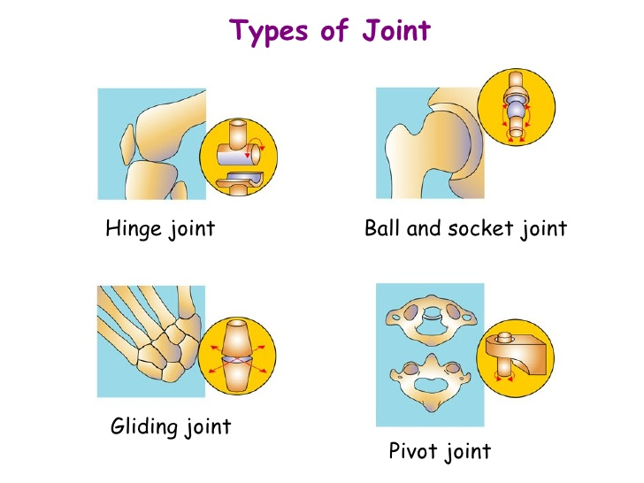
______________________________________________________________________________________________________________________________________________________________________________________

- Explain the path of food through the digestive system and what happens in each organ.
________________________________________________________________________________________________________________________________________________________________________________________________________________________________________________________________________________________________________________________________________________________________________________________________________
- Explain the difference between chemical and mechanical digestion and give an example of where each happens.
____________________________________________________________________________________________________________________________________________________________________________________________________
- How does the diaphragm help you breath?
__________________________________________________________________________________________________
- What is the difference between breathing and respiration?
__________________________________________________________________________________________________
- List each system and provide an example of how it interacts with two other systems.

