Name: _______________________________________ Vocabulary Choice Board ADVANCED
Flash cards due Wednesday February 15th, other choices Due Friday February 17th .
You will choose 3 options; one of which must be the middle and one choice must be a corner option. *You cannot use the same words for your 2nd and 3rd choices.
Create a “meme” for 10 words that helps explain what the word means.  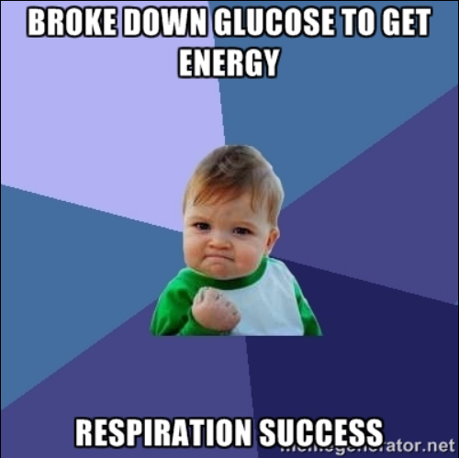  Be sure to include the term with each. | 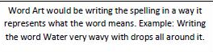  Make Frayer Models for at least 10 vocabulary words. 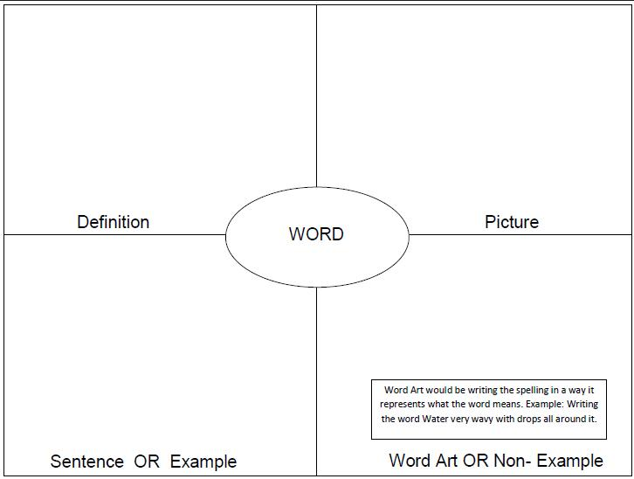 | Make a song that includes at least 5 vocabulary words. The song should be at least 1 minute long when sung.
Comic Strip  You can draw one comic strip that uses at least 5 of the words or create a separate strip for each word.  (www.makebeliefscomix.com) | Required Vocabulary Activity  Create Flash Cards for all vocabulary.  This can be handwritten on index cards or using Quizlet. | Make a booklet of at least 10 words and their meaning using your own drawing.
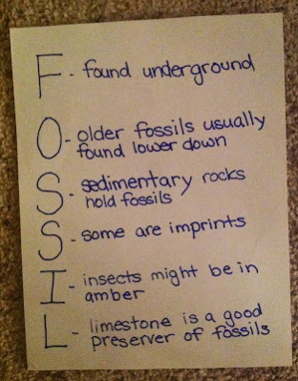  Make an acrostic for at least 5 of your vocabulary words. The words you choose for each letter should be related to the word written downward. | Using at least 15 of your vocabulary words, create a crossword puzzle. Be creative in the clues that you use. Do not always use the definition for that clue. | Use at least 5 of your vocabulary words in a children’s story with illustrations. The story must explain the words in a way that a second grader could understand.

1. Heredity
2. Trait
3. Genetics
4. Mendel
5. Gene
6. Allele
7. Dominant trait
8. Recessive trait
9. Probability
10. Punnett Square
11. Heterozygous
12. Homozygous
13. Genotype
14. Phenotype
15. Chromosomes
16. Meiosis
17. Base Pair
18. Franklin.
19. Watson and Crick
20. DNA
21. Double Helix
22. Mutation
23. Nitrogen Bases
24. Sex-linked genes
25. Selective Breeding
26. Human Genome Project
27. Carrier
28. Genetic Engineering
29. Stem Cell
30. Sexual reproduction.
31. Asexual reproduction
32. Budding
33. Haploid

