Name: _______________________ Date: _______Introduction to Fossils and determining age of the rocks
What is a fossil? ___________________________________________________________________________________________
How do fossil Form?
In order for a fossil to form, an animal or plant must be ____________ into a material. In many instances, fossils are found in ____________. Layers of sediment will ___________ the remains. This can continue for ________________ of years. The actual remains that are found aren't the animal or plant at all. Instead, the remains begin to ______________ within the sediment. _____________________ then replace the space that was once the remains. The mineral hardens and makes an ___________________________ of the animal or plant. What is left is what is known as a ___________________________.

What parts of an organism will form a fossil?
The _____________ parts of an animal or plant decay more quickly than its hard parts, therefore ____________and _____________ are more likely to be preserved than skin, tissues, and organs.
Types of fossils:
Mold:_______________________________________________________________________________________
Cast:________________________________________________________________________________________
Petrified fossil:_______________________________________________________________________________
What is the fossil record: _____________________________________________________________________
____________________________________________________________________________________________
It provides _____________________about the history of life on Earth and how different groups of organisms, including species, have _____________________________________________________.
To understand how living things have changed through time, scientists need to be able to determine the ________________ of the fossil. Scientists can determine fossils age in two ways:
_____________________ and ________________________. The fossil record provides information about species that are ___________ (or have died out).
- Relative dating:
Scientists look at where the rock is ____________. The older layers are ____________ than the layers above. This method only provides an ___________ age of a fossil. The __________ age cannot be determined; you can only say that something appears earlier or later than something else.
- Radioactive dating:
Scientists determine the actual age of a sample based in the amount of remaining _________________________ it contains. Calculations are based on _______________ .
Half-life:___________________________________________________________________________________
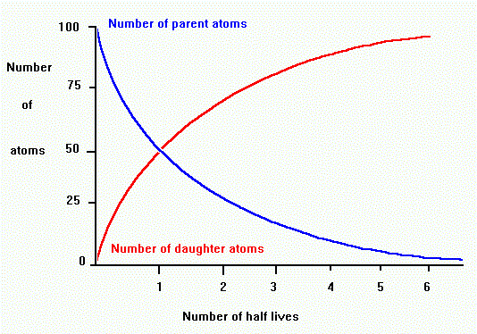
What the graph tells us: The proportion of parent to daughter tells us the number of______________, which we can use to find the age in years. For example, if there are ___________________ amounts of parent and daughter, then ___________________ half-life has passed.

