Name: ____________________________________ Date: ______________ Darwin’s Voyage Notes

Charles Darwin
- A _____________________ (a person who studied nature) on an observation trip to the Galapagos Islands.
- He set sail on the _________________________ in 1858 from England on a 5 year expedition.
Galapagos Islands
- Located in the ___________ __________ , Northwest of ___________ ______________.
- The islands were formed by undersea ______________________, almost 5 million years ago.
What did Darwin find on his voyage?
- He found a _______________________ of _______________________ similar to those found in South and Central America.
- He also encountered new and unusual organisms while on his voyage, especially on the _______________.
What did Darwin observe on his visit to Galapagos Islands?
- Darwin observed similarities and differences between the individual _____________ and the ________________________ organisms.
- Darwin wondered why these organisms had __________________ characteristics from those on the mainland.
- He concluded that these organisms faced conditions that were different to that of the mainland.
- As a result they had to develop ___________________ or traits that helped the organisms’ ____________.
What did Darwin hypothesize?
- Darwin hypothesized that a _______________ number of different plant and animal species had come to the ___________________________________.
His hypothesis is an example of __________________ and ___________________ or _______________.
Dispersal
- Defined as the movement of organisms from one location to another
  - Some might have _____________________ to sea during a storm
  - Some may have set ______________________ on a fallen log
- Once the plants and animals reached the islands, they ____________________________.
- Eventually their offspring became ______________________ from the mainland species.
Three conclusions that Darwin made during his voyage were:
- ________________________________________________________________________
- ________________________________________________________________________
- ________________________________________________________________________
What is adaptation?
- It is a _______________________ that helps an organism to survive in its environment.
How did Darwin’s voyages and observations lead to the theory of natural selection?
- He hypothesized that the species _____________________________ over many generations and became ___________________________ to the __________conditions.
- The gradual change in an organism’s genetic makeup leads to the development of _____________ ________________.
- From his voyages, Darwin wrote a book called “_______________________________.”
What is natural selection?
- _______________________________: means that organisms with traits best suited to their environment are more likely to ________________________ and ____________________________.
Results of natural selection
- The offspring will inherit these _____________________ traits and will be more likely to ____________________ and ________________________.
- Over time ____________________ variations may gradually _____________________ while ______________________________ ones may ___________________________.
Factors that affect natural selection are:
- Over-production – where organisms produce more offspring than can survive.
- ____________________ are found among individuals of a species (some may move faster, hard shell, or keen eye sight). Some variations allow members of a population to ___________________ and __________________________ better than others.
What is variation?
- It is a(n) ______________________________ (change in the DNA) that makes an individual _________________________ from other members of the same species.
- Can be ______________________ , _____________________________, ____________________________, and _____________________________________.
- Competition - where organisms ____________________ for the same _____________________and other _________________________ in a restricted or specific space.
Genes and natural selection:
- Darwin could not explain what caused variations or how they were passed on.
- Today we know that they can result from both mutations and the shuffling of alleles during meiosis.
- _______________________ are passed from parent to offspring on chromosomes, because of this, only ____________________________ that are controlled by genes can be acted upon by _________________.
Evidence of evolution:
- ______________________________________: A new species will form when a group of individuals remains ________________________ from the rest of its species long enough to evolve different traits. Isolation can occur from a ________________, a ____________________, or a __________________________________.
- Homologous structures: Similar structures in a variety of different organisms. _______________________ provides evidence that the organisms had a shared common ancestor with that trait.
What are homologous structures? These are body parts that are similar in both ___________________ and ________________________. Examples: ____________________________________________.
- _____________________________ - organs that serve _____________ useful function in an organism. Example: gills and tailbones in humans.
- __________________________________________ - In their early stages of development, chickens, turtles and rats look similar, providing evidence that they shared a __________________________.

What similarities do you see between these embryos?

Branching Tree:
- A ___________________ or _______________ that shows how scientists think different groups of organisms are related.
- Scientists use all the evidence available to make a _______________ (Body structure, embryology, DNA, and fossil record Etc.)
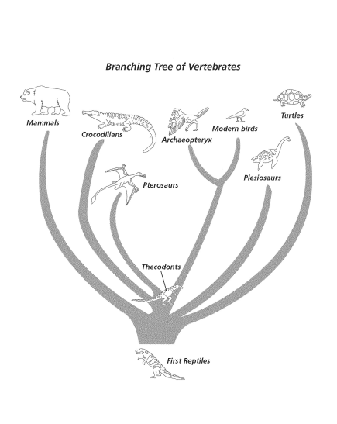
Use the diagram bellow to answer the following questions:
Did birds evolve from Pterosaurs? _______________
What is the common ancestor of Crocodilians and Modern Birds? ____________________________
Are modern birds more closely related to Archaeopteryx or to the first reptiles? ________________

Summary of Darwin’s Theory:
- _______________________________ in nature differ from one another
- Organisms in nature produce more ___________________ than can ______________________, and many of those who do not survive do not reproduce.
- Because more organisms are produced species may struggle for ____________________.
- Each organism is ______________________, each has advantages and disadvantages in the struggle for existence.
- Individual(s) ___________________suited for the environment survive and reproduce most successful.
- _________________________change over time.
Evolution can occur in two ways:
- Gradualism: A _______ ___________ process where you can see different forms of the new species. Minor changes occur.
- Punctuated equilibrium: Happens _______________. Sometimes ________________ species are not there. Species branch off and evolve simultaneously.

