Name _______________________________________________ States of Matter: Phase Changes
Directions: Look a the diagram below. Using the word bank below, write the labels in the correct boxes.

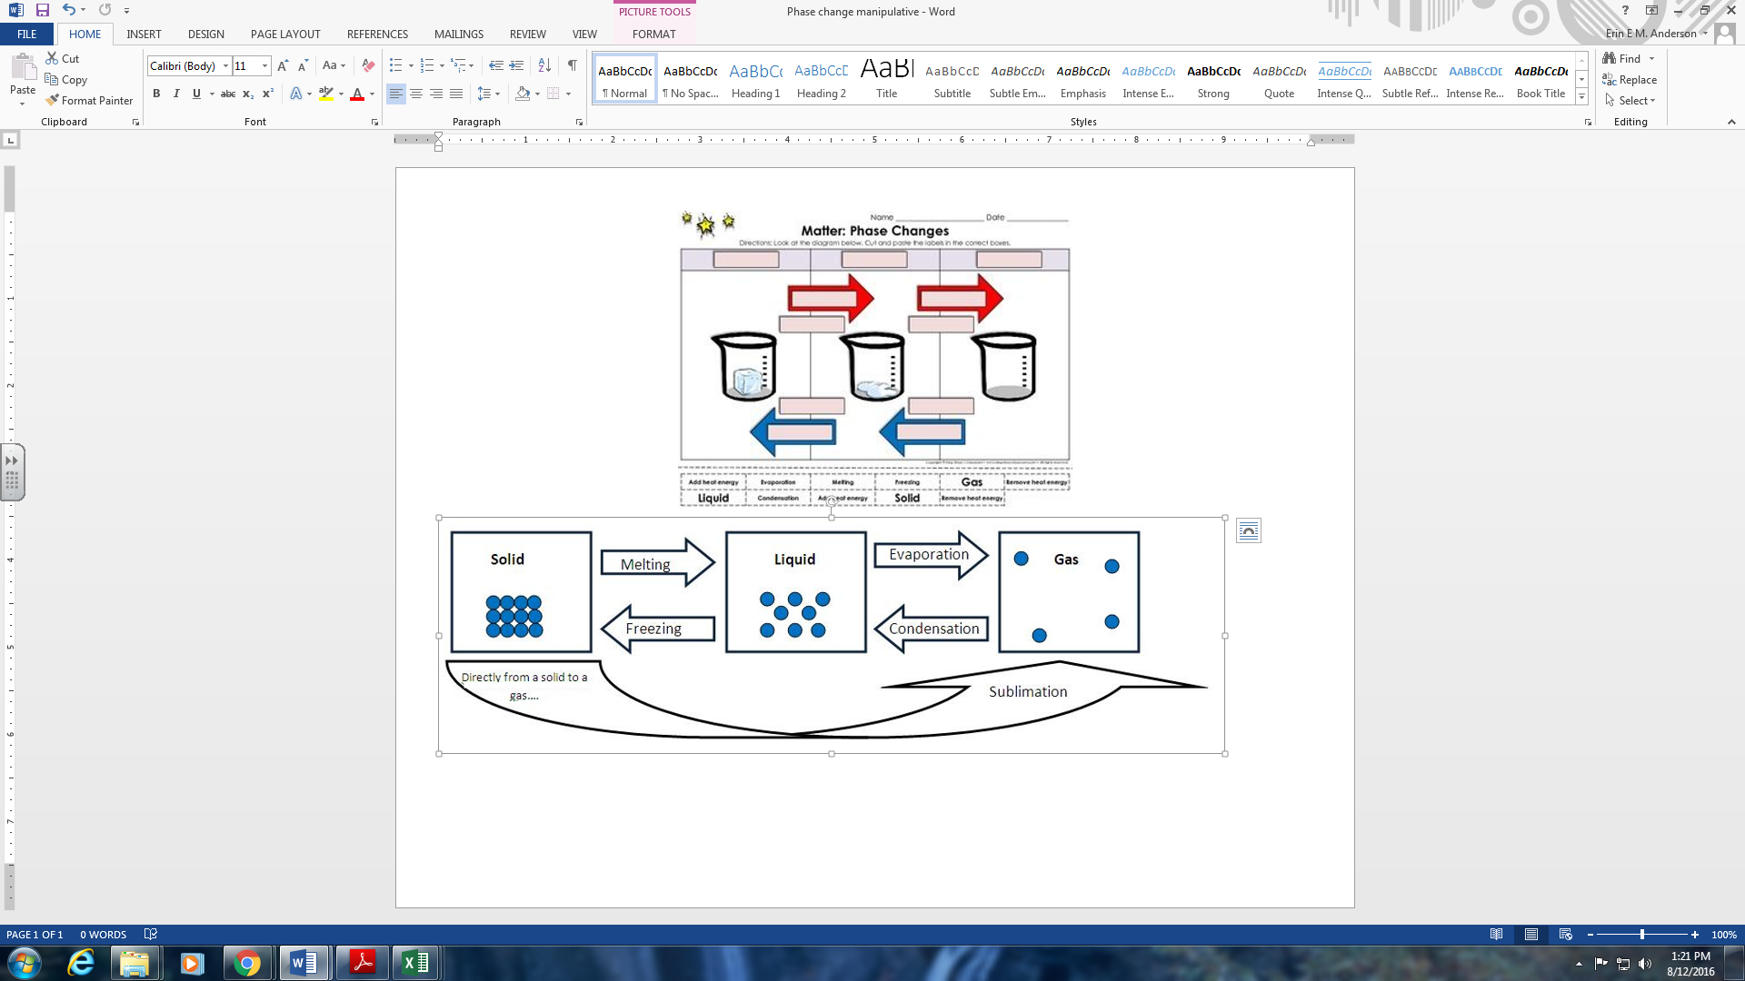

Word bank: Check them off as you write them into the correct spot.
______ Add heat energy ______ Evaporation ______ Melting ______ Freezing ______ Gas
______ Remove heat energy ______ Liquid ______ Solid ______ Condensation
______ Add heat energy ______ Remove heat energy

Name _______________________________________________ States of Matter: Phase Changes
Directions: Look a the diagram below. Using the word bank below, write the labels in the correct boxes.

