1. A Sound wave is a __________________________ because it has to ___________________________.

2. A Sound wave is also a ______________________________ because matter in the medium moves ________

_____________________ along the _________________________ that the wave travels.
A. ______________________

B. ______________________

C. ______________________
3. Identify the parts of the Compressional (Longitudinal) Wave for review.

A.
B.
C.

4. In the box to the right, draw an illustration to show how a
compressional wave is different from a transverse wave.

5. ______________ is the human perception of how much ____________ a sound wave carries.

6. In a compressional wave, the ___________________ is _____________ when the particles of the medium

are _______________________ in each compression and __________________________ in each rarefaction.

7. ______________ Amplitude = __________ Sound Smaller ______________ = Softer _____________
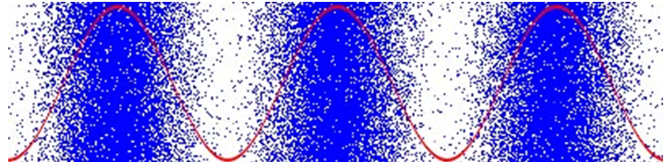
Figure 1
Figure 2
8. Which one of the
figures has the highest
amplitude? Explain
your answer.

__________________________________________________________________________________________

9. The _________ of a sound is how _________ or _______ it sounds.

10. The _________________ of a sound wave is the number of _________________ that pass by a given point.

11. The ___________ the __________, the _______________ the ______________.

12. An object that vibrates __________ forms a sound wave with a _________________________________.

13. Which one of the
figures has the
highest pitch?
Explain your answer.
Figure 1
Figure 2

__________________________________________________________________________________________

14. The ___________ carried in a ___________ wave can be described in ___________________.

