Electricity Cloze Notes
_______________is generated from the motion of tiny charged atomic particles called electrons and protons. Electrons in different energy levels can ______ from one atom to another. These jumps change the overall ________of the atoms. The change in charge results in ________________________.

_______________ _____________is the flow of electric charges. Electric current is measured in _________(A), or amps. __________________ will always flow from a region of _______ potential energy to a region of _____________ potential energy. This potential difference is known as ____________________ and is measured in ______________. A ______________ is a device that converts chemical energy into electricity. In batteries, the potential energy difference is created by the ______________ and _____________ terminals.

A ________________is a path through which electricity can flow.

A circuit needs an __________ ____ _______to ______________ a charge through the circuit. The ___________________ is the ______________________.

A circuit will also require a_______________________. A ________________________is a material that ________________ electrical energy to flow through it easily. ___________________ make good conductors, so wires from metals are most often the conductors.

A circuit also needs a __________________. A__________________ is a device in an electrical circuit that ____________________ energy. Examples of loads are: ______________________________________________________________________________________________________________________________________

A circuit may also contain a _______________________. A ___________________ is a device that is used to ________________the flow of current through a circuit. When a switch is _____________, the path is broken, so ________________ flows through the circuit. When a switch is _____________, it creates a continuous path through which an electric charge __________________.
Energy flows only through a circuit that is _______________.

A _______________ ___________________is a circuit that provides only ______________ possible path for the flow of current. In a series circuit, the loads are set up in a series, or __________________, that requires current to flow ___________________________before passing through the next.
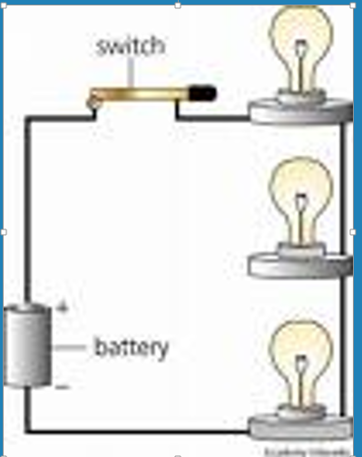

A ______________________________offers _____________ ______________ ________________ path for the flow of electricity. Each ________________in a parallel circuit has ________ ________ closed circuit pathway to the energy source. Loads in a parallel circuit use the _______________ ___________________ of the energy source.

