____Electricity_____is generated from the motion of tiny charged atomic particles called electrons and protons. Electrons in different energy levels can _jump_____ from one atom to another. These jumps change the overall __charge______of the atoms. The change in charge results in ___electricity_____________________.

______Electric___ ___current________is the flow of electric charges. Electric current is measured in ___Amperes______(A), or amps. ____Electric charges____ will always flow from a region of _high______ potential energy to a region of __low_____ potential energy. This potential difference is known as _voltage_________ and is measured in __volts___. A ___battery___________ is a device that converts chemical energy into electricity. In batteries, the potential energy difference is created by the _positive___ and ____negative_________ terminals.

A __circuit______________is a path through which electricity can flow.

A circuit needs an ___energy source__ _______to ___push___________ a charge through the circuit. The ___energy source________________ is the ____battery__________________.

A circuit will also require a__conductor_________. A ____conductor_______is a material that __allows___________ electrical energy to flow through it easily. ____Metals_______________ make good conductors. So wires from metals are most often the conductors.

A circuit also needs a ___load_______________. A____load_______ is a device in an electrical circuit that __uses__ electrical energy. Examples of loads are: ___light bulbs, bells, radios, motors______

A circuit may also contain a ___switch____________________. A ________switch___________ is a device that is used to __control______________the flow of current through a circuit. When a switch is ____open_________, the path is broken, so __no electricity_____ flows through the circuit. When a switch is ___closed__________, it creates a continuous path through which an electric charge __can flow________________.
- Energy flows only through a circuit that is __closed_____________.

A __series circuit____is a circuit that provides only ___one___________ possible path for the flow of current. In a series circuit, the loads are set up in a series, or ___line_____, that requires current to flow __through one load______before passing through the next.
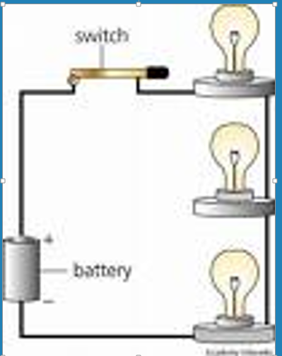
A _____parallel cicuit____offers ___more than one ______ path for the flow of electricity. Each ___load_____________in a parallel circuit has _its own_______ ________ closed circuit pathway to the energy source. Loads in a parallel circuit use the ___full voltage___ of the energy source.
