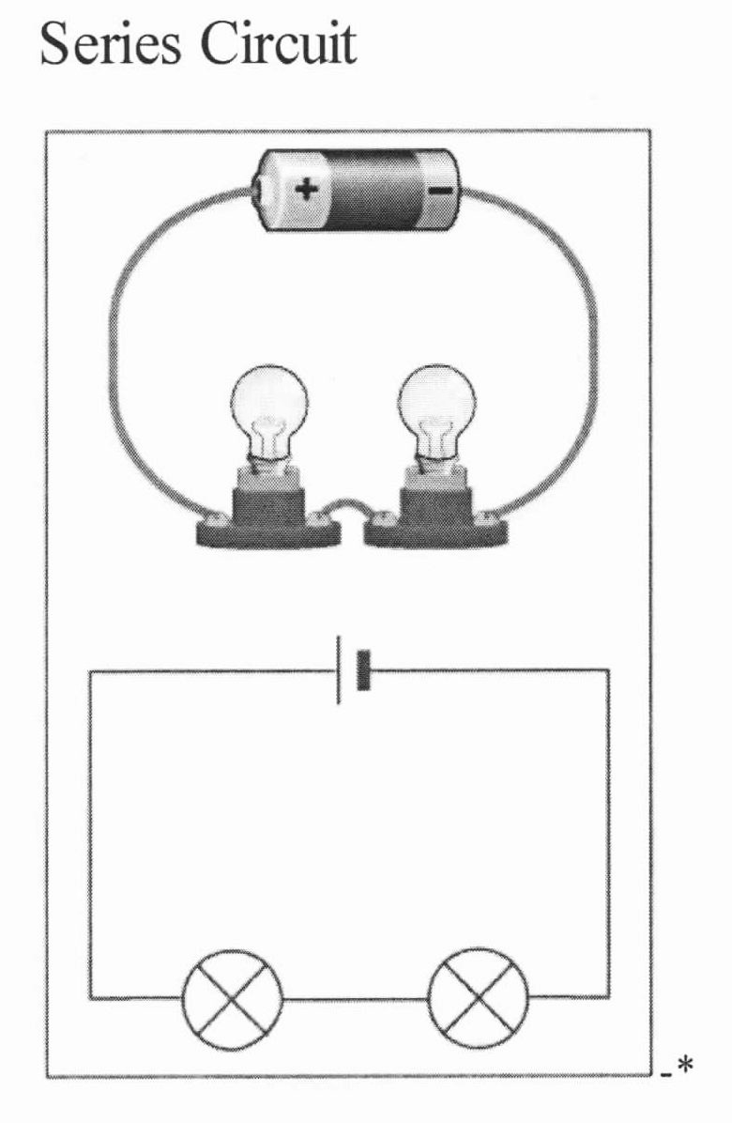
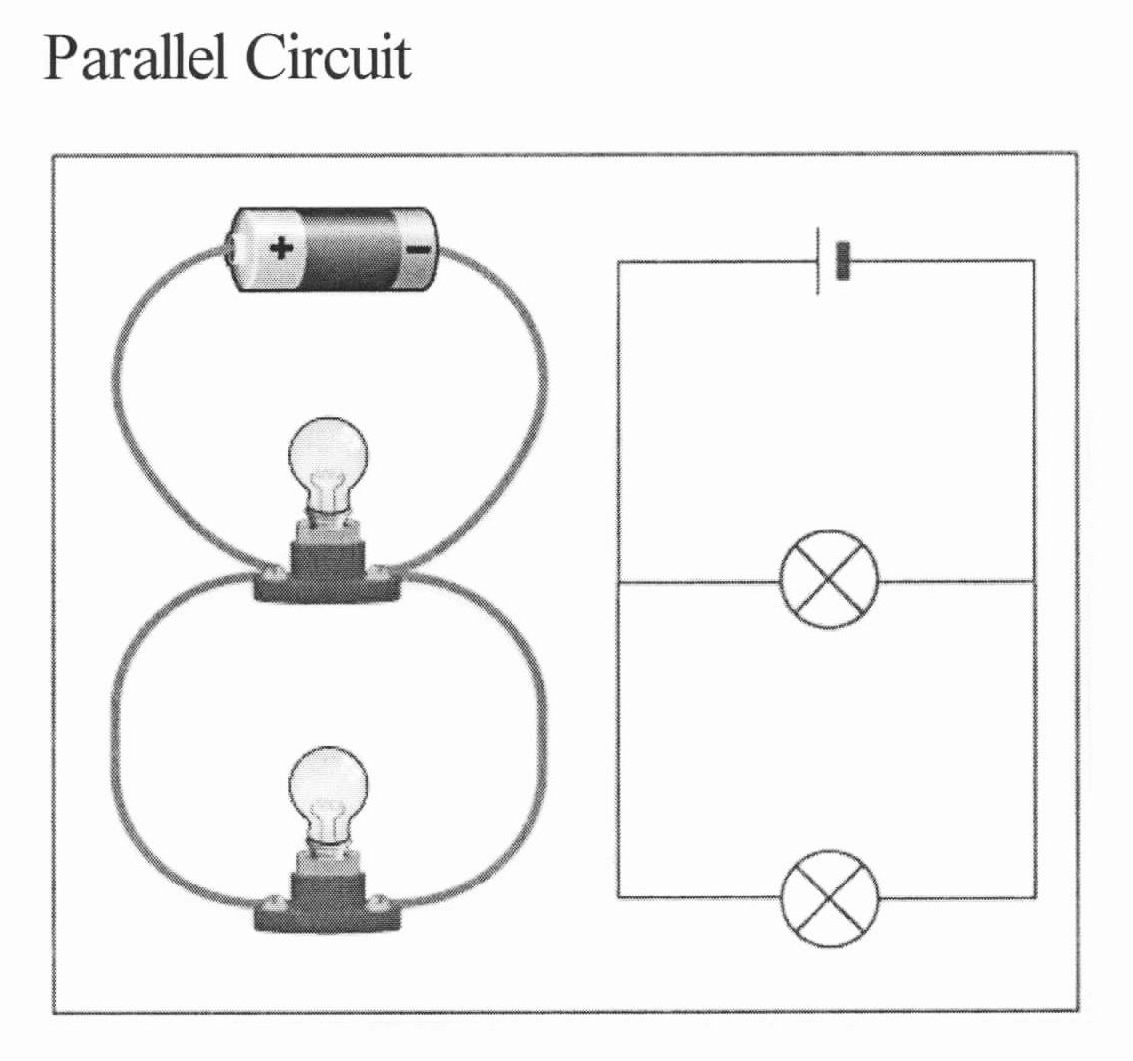
Circuits Venn diagram

Series Parallel

Circuits Venn diagram

Series Parallel

