Magnets and Magnetism Notes

Magnets

- A magnetic ________________________________ is a ________________________ or _______________________ that is exerted by a ___________________________.
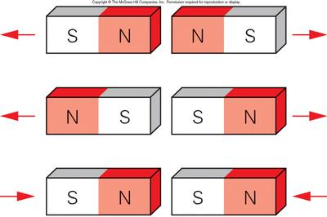
- A magnet has two ___________________.
  - ________________________ and _________________________ ends

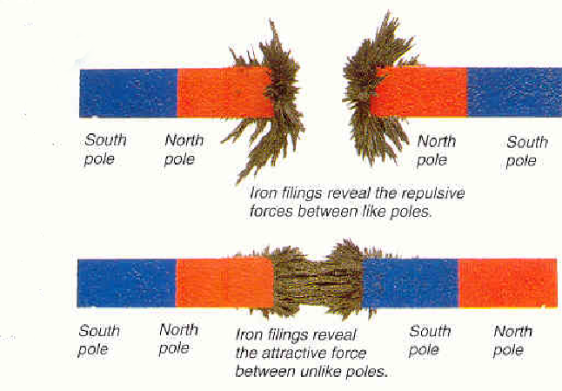
- Poles that are alike ____________________________ or push apart.
- Poles that are not alike ____________________________ or pull together.

- The area _______________________________ a magnet in which a magnet force exists is called the _______________________________ ____________________.

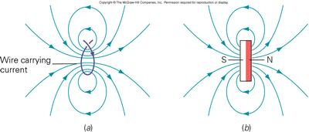

- The production of a __________________________ ___________________ by electric currents is called _________________________________________.
- A magnet that is made by passing an ________________________ ____________________ through a coil of wire wrapped around an _________________ ______________ is called an ___________________________________.
- An _________________________________ consists of an iron core placed inside a wire coil. The magnetic field ____________________ of a wire coil carrying an electric current increases in direct proportion to the ______________________ of turns of the coil.
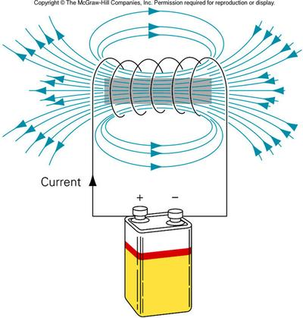
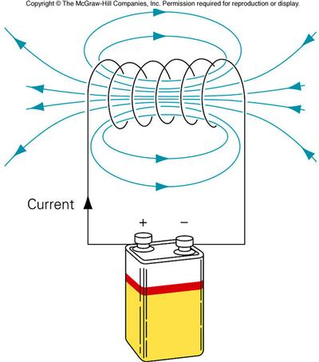

Changing the Strength of an Electromagnet:

To Increase Strength | To Decrease Strength
Increase the strength of ___________________ (bigger energy source) | ____________________________ the strength of the current
Add more ______________ of wire | Use _________________ coils of wire
Increase the size of the _______________ core. | ______________________________ the size of the iron core.

Uses of Electromagnets
- A ____________________________ is a device that transforms mechanical ___________________ into __________________________________ energy.
- The electrical systems of many _________________ use electricity produced by _______________________________ to work.
- An ____________________________ ______________________ is a device that transforms electrical energy into mechanical ____________________________.
- ________________________________ and _________________________ are two appliances that operate using motors.

