Static Electricity Cloze Notes

What is Static Electricity?
- A stationary ______________________ _______________ that is built up on the surface of a material
- Two kinds of charges involved in static electricity: __________________ and _______________________

Where do charges come from?
- Matter is made up of __________________.
> found in the nucleus
  - Protons - ___________________ charge
  - Neutrons - __________________ charge
  - Electrons - __________________ charge
- If the # of electrons = # of protons then it has a ____________________ charge
- If the # of electrons > # of protons, then it is __________________ electrons, and has a ____________________ charge
- If the # of electrons < # of protons, then it is __________________ electrons, and has a ____________________ charge

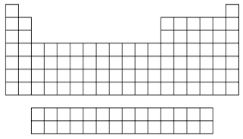
Electronegativity - the measure of the tendency of an atom to __________________ a bonding pair of _______________________.
Elements here are more likely to gain or lose electrons when bonding (positive and negatively charged atoms)

Rubbing materials __________________ does ____________ create electric charges. It just transfers electrons from _________ __________________ to the other.

Insulators: materials that _____ ________ allow electrons to _____________ through them easily.
- Insulators can be easily _____________ by _____________ as the extra electrons gained _______________ easily escape.

Conductors: materials that ______________ electrons to flow through them easily.
- Conductors ________________ be easily charged by friction as the extra electrons ________________ can easily escape.

Charging by Friction
- Caused by ________________ two different substances together (_________________)
- When the objects are rubbed together, one object will ___________ electrons and another will ___________ electrons

Charging by Contact
- ___________________ (or neutral) objects can become charged if they come into contact with charged objects.
- When an uncharged object is charged with a neutral one, it will ___________ ______ the same charge as the one that touches it.
- Example: If a _________________ charged metal rod touches a ball, the ball will become __________________ charged. Since they now have the same charge, they will repel each other. Remember, like charges ____________!
Charging by Induction
- Requires a ___________________ object to be moved near a neutral one (cannot touch)
- When charging by __________________, the once neutral object always takes on the ________________ charge to the object that approached it.
- Example:

Grounding: What is grounding?
- An object is grounded when it is ___________________ to the ___________ through a connecting wire.
- If a charged _____________________ is grounded, it will become __________________.

Lightning
- A natural process where electric charges are _________________ through the air.
- The jagged path is cause by the electric charges trying to find the _________ path to the ground.
- The electrical charges are drawn to tall buildings because these __________________ their path to the ground.

Lightning Rods
- A metal rod (a _______________) placed on the top of a building, and is long and pointed so it will be the tallest part of the building.
- The rod should be the part of the building first hit by the lightning and then should ______________ the lightning into the ground.
- Lightning ____________ seeks the fastest route to the ground.

Check for Understanding: A balloon has a ______________________ charge when rubbed by a woolen cloth.
- If the balloon can attract some paper scraps, which of the following cannot be the charge of paper scraps? ____________________________
- During rubbing, what have been transferred between the woolen cloth and the balloon? __________________________
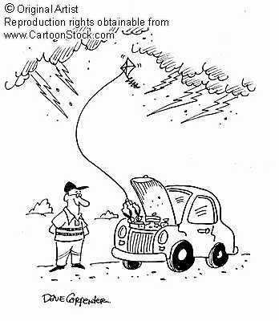
Write a paragraph about the cartoon. Tell what he is trying to do. Will it work and why? What do you think will happen? Use the following words: static electricity, lightning, electrons, positive and negative charges.
_________________________________________________________________________________________________________________________________________________________________________________________________________________________________
_________________________________________________________________________________________________________________________________________________________________________________________________________________________________
_________________________________________________________________________________________________________________________________________________________________________________________________________________________________

