Velocity and Acceleration Cloze Notes

S8P3. Students will investigate relationship between force, mass, and the motion of objects.
a. Determine the relationship between velocity and acceleration.

Speed
- A __________________ is a push or a pull
- When a force acts on an object, one possible result is __________________.
- A ________________________ _____________ is generally a stationary object such as a tree, a street sign, or a line on the road.
- Once a reference point has been established, it is possible to define the ____________________ of an ________________ in terms of _____________________, ____________________________, and _____________________________.
- The _______________________ of an object refers to how fast an object moves.
- To determine speed you need to know both the ________________________ an object _______________________ and the amount of __________________ needed to ____________________________.
- Calculations using formulas:
  - Most objects do not move at a constant, unchanging speed.
  - When you use the formula to find the speed of an object you’re actually finding the object’s ________________________ _______________________.

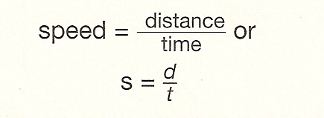

D

S T

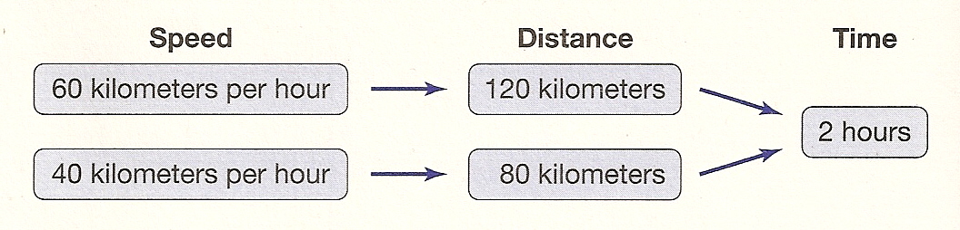
- The diagram shows how two automobiles with different speeds move during the same amount of time.

- Speed can be shown on a graph of _____________________________ vs _______________.
- Notice that the line of this graph is not straight. This is because the object’s speed ________________________.

Velocity
- ________________________ is the speed of an object in a _____________________ ________________________________.
- Suppose that two cars traveled at 50 kilometers per hour on the same highway for 2 hours. After two hours, the cars are 200 kilometers away from each other.
- How is this possible? They were traveling in opposite directions.
- _____________________ describes _____________________________ and _____________, but does NOT indicate __________________________.
- When the ______________________ of an object’s _________________________ is included, you are describing an object’s __________________________.
- Velocity _________________________ when the _________________________ or the ____________________________ of an object changes.

  - If a sailboat’s speed goes from 4 knots to 7 knots, its ______________________ has changed. If the sailboat continues moving at 7 knots, but changes _________________________, its velocity has again changed.

Acceleration
- ____________________________ is the rate at which an object’s velocity changes.
  - _______________________ changes when an object’s speed and direction changes.
  - ___________________________ of an object also changes if its speed or its direction changes.
- You can calculate the ________________________ _________________________________ of an object by using the following equation.
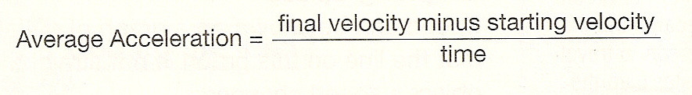

- ___________________________ is recorded in units such as meters per second squared (m/s²).
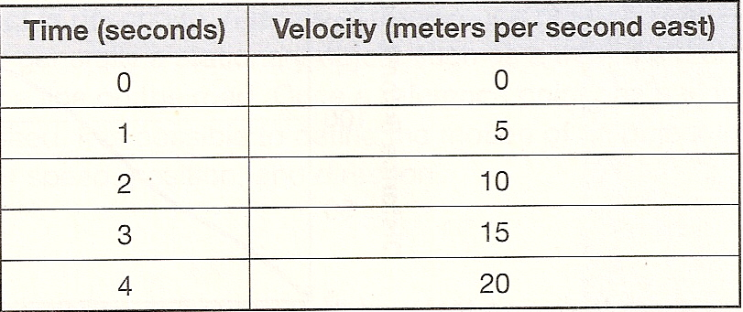
- Acceleration of a Car Example:
- Based on this data, you can see that the acceleration of the car at any time is 5m/s/s or 5 m/s^{2.} Every second, the velocity of the car increases by 5 m/s.

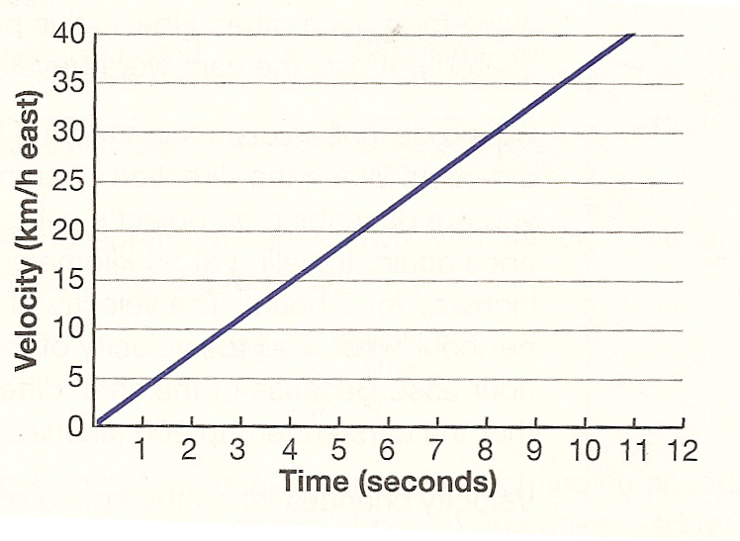
- Assume that the following graph plots your acceleration (velocity vs. time) during a car trip. The graph shows that at 10 seconds, the velocity of the car was 35 kilometers per hour east.

- These equations can be used to calculate the average acceleration of the car.

