**KAHFOOTY**

**K**eep

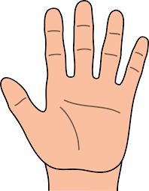**A**ll

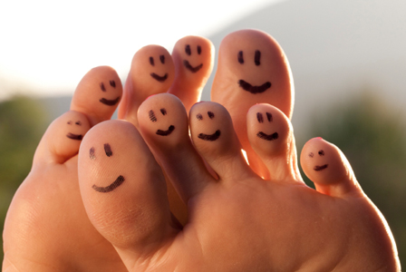**H**ands,

**F**eet, and

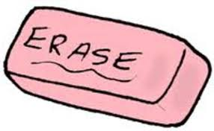**O**ther

**O**bjects

**T**o

**Y**ourself