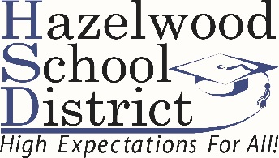

ENROLLMENT CHECKLIST

The following items are needed in order to enroll your child/children in the Hazelwood School District.
If you are unable to provide any of the required documents, please contact 314/953-5000 for assistance

______ 1. Original state-issued birth certificate for the student (the enrolling parent must be listed on the document)

______ 2. Current immunization records for the student (all shots must comply with Missouri state law)

______ 3. Transcript for students in grades 9-12 or most recent report card for students in grades K-8

______ 4. Discipline record from previous school (this applies to students entering grades 6-12)

______ 5. Current driver’s license or state I.D. card of the enrolling parent or legal guardian

______ 6. Current Individual Education Plan and Evaluation (IEP) and/or 504 Accommodation Plan (if applicable)

______ 7. PROOF OF RESIDENCY (current proof of residency is required before enrollment and registration)

___ A. Deed of Trust or current estate tax receipt, two unpaid utility bills and a valid occupancy permit.
*In addition, if the parent or guardian is not listed on the deed or tax receipt, however, he/she is
married to the property owner, a copy of the marriage certificate will need to be provided.

___ B. Current apartment lease, two unpaid utility bills and a newly-issued occupancy permit.
A new lease and two unpaid utility bills will need to be provided when the lease expires.
*In addition, if the parent or guardian is not listed on the lease, however, he/she is
married to the leaseholder/renter, a copy of the marriage certificate will need to be provided.

___ C. Current house lease from a private individual, two unpaid utility bills and a newly-issued occupancy
permit. A new lease and two unpaid utility bills will need to be provided when the lease expires.
*In addition, if the parent or guardian is not listed on the lease, however, he/she is
married to the leaseholder/renter, a copy of the marriage certificate will need to be provided.

