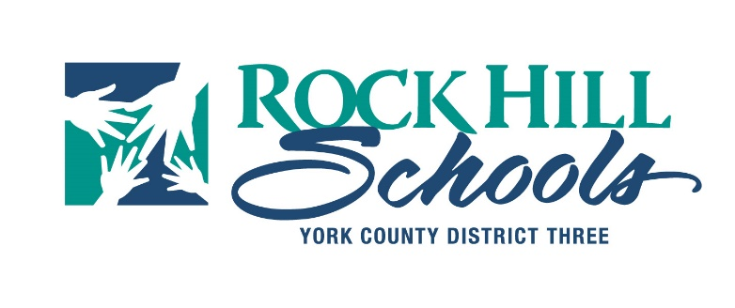
Based upon USDA Nutrition Standards and School Board Policy ADF - District Wellness, the following list of approved snacks are the only allowable snacks for classroom celebrations or parties. No homemade goods are permitted. Snacks must be individually wrapped or in purchased container/package with a food ingredient label.
Valentine’s Day parties are excluded from using the list.
The list was compiled by the district Health Advisory Committee using feedback from the School Improvement Councils (during the 2017-18 school year), parent survey responses from the spring of 2018 and feedback from the Coordinated School Health Advisory Committee.
Pretzels
Cheddar crackers or graham crackers
Sun chips or similar baked chips
Frozen fruit bars (Ex. Whole Fruit, Outshine, Dole or store brand equivalent)
Fresh fruit – Individual serving/wrapped or in purchased package container
Fresh vegetables – Individual serving/wrapped or in purchased package container
Low fat dips
Fruit cups (Ex. In water, light syrup, or 100% juice)
Yogurt
Apple sauce cups
Gelatin cups or pudding cups
Fruit and veggie pouches
Cheese sticks (Individually wrapped)
Pepperoni or turkey pepperoni (In purchased package container or individual sticks)
Water/Flavored Water
*This list does not address allergies. Please remember to always check specific allergies with your classroom teacher 48 hrs. prior to bringing food to the school. Accommodations will be made for students with allergies.

