Naviance Student Overview

# Overview

Naviance Student makes it easier than ever for you to answer the questions that will shape your future: Who am I? What do I want to be? How will I get there? and How will I succeed?

Naviance Student is a mobile-responsive site that employs tools to personalize and simplify the college and career planning process.

## Accessing Naviance Student

Navigate to Naviance Student using your device’s internet browser. [School Name’s] Naviance Student platform can be accessed using the following address:

[www.student.naviance.com/[schoolalias](http://www.student.naviance.com/%5bschoolalias)]

Replace with information for SAML or CLEVER Accessibility as needed and then DELETE this sentence. If you use either of these tools for Single Sign On, the two sections below are no longer needed.

### It is suggested that you bookmark the site’s address on frequently used devices to easily return to Naviance Student.

# Getting Started

## Logging in to Naviance Student

|  |  |
| --- | --- |
| Scenario 1: You already have a username and temporary password provided by your school | Scenario 2: You have a registration code provided by your school. |
| 1. Visit your Naviance Student login page 2. Select Student 3. Enter your username and temp password 4. Follow the prompts to create a new, permanent password 5. Log in with your new credentials | 1. Visit your Naviance Student login page 2. Select I’m New and Need to Register 3. Enter your registration code and follow the prompts to set up your own permanent username and password 4. Select Student and enter your updated credentials to login |

## Static Toolbar



1. Favorites: Easily access any list of your favorites.
2. Leave Feedback: Want to share some thoughts on Naviance? Use the Leave Feedback icon to take a survey about the Naviance experience.
3. Email Inbox & Notifications: Your Naviance account has its own inbox to receive messaging from your school. Use this icon to access the inbox.
4. About Me: Use this drop-down to access and edit account information, build and review items such as your resume and journal, and access surveys.
5. Log Out: Log out of Naviance Student.

## Menus

The Naviance Student menus are mobile-responsive and will adjust based on the device you are using. Select a menu to see the additional options available.

|  |  |
| --- | --- |
| Mobile | Desktop |
|  | *The menu options you have visible may change based on the sections available at your school.* |

# Naviance Student Sections

The following menus and sections are available in Naviance Student based on your school’s setup. Below are the common menu options followed by overviews of each section’s home page and key features.

1. Home: Get a quick glance at your account, including a welcome message, important to-dos and tasks, your favorites, and new college visits and other events.
2. Self-Discovery: Take assessments to help you learn more about yourself and your potential career interests.
3. Courses: Manage your course plans, including required credits and other important criteria laid out by your school or district.
4. Careers: Explore and favorite careers of interest, access our Roadtrip Nation videos to learn more about different career and professional pathways.
5. Colleges: Search for and discover your best fit college possibilities.
6. Planner: Define and manage your goals, to-dos, and tasks that have been assigned to you by your school or district.
7. About Me: Access and edit account information, build and review items such as your resume and journal, and access surveys

# Show Me How Feature

The Show Me How feature can be used to find guided tours that will teach you how to use features in Naviance Student. The feature can be found in the bottom right corner of Naviance Student. When the widget is opened, you can use the categories or search feature to find tours. New tours are often being added.

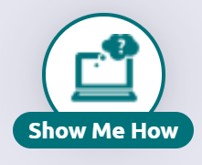

# The Home Page

From My School: From this section, find a list of links, pages, and updates provided by your school. Use View all from my school to see a full list.

My Favorites: Quick access to your Colleges I’m Thinking About, Colleges I’m Applying To, and Careers and Clusters I’m Thinking About.

What’s New: View upcoming college visits, new journal entries shared by a counselor or teacher, and any new comments on course plans, tasks, and goals made by someone other than you.

Resources to Get Ready: Everyday access to Document Resources -documents shared by the school with all students. This area also provides access to Test Prep, x2VOL, and Curriculum if your school uses them.

Important To-Dos and Tasks: Drawing from your planner, get a snippet of overdue and upcoming to-do items and tasks.

Welcome Card: A custom message from your school.

# Self-Discovery

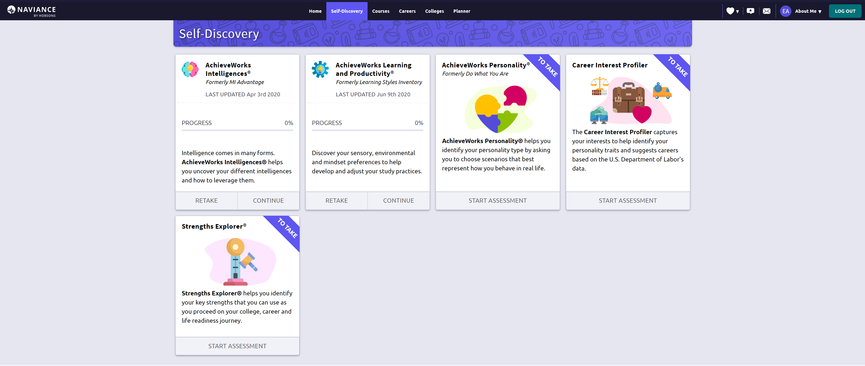

Start Assessment: For any assessments that you have yet to take, use the Start Assessment option to begin the assessment. Each assessment has a quick overview of its purpose.

Retake and Continue: Use the Retake option to retake an assessment that you have started. Use Continue to finish an assessment that you have started but not finished.

Progress Bar: Quickly see how far along in the assessment you are before continuing.

The assessments available in the Self-Discovery section will be dependent on which assessments your school or district has shared. Some of the assessments may include:

* AchieveWorks Intelligences: Uncover your different intelligences and how to leverage them
* AchieveWorks Learning and Productivity: Discover your sensory, environmental and mindset preferences to help develop and adjust your study practices
* AchieveWorks Personality: Identify your personality type by choosing scenarios that best represent how you behave in real life
* Career Interest Profiler: Capture your interests to help identify your personality traits and suggest careers based on US Department of Labor’s data
* Strengths Explorer: Identify your key strengths to use as you proceed on your college, career, and life readiness journey

# Courses

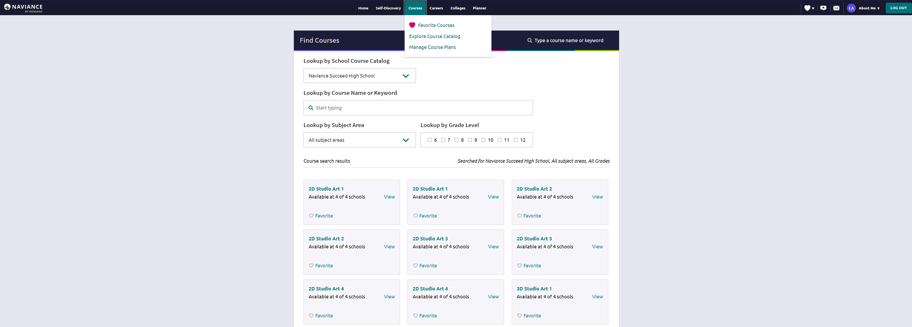

If your school uses the Course Planner exerience, you will see the Courses menu. From here, you may be able to find favorite couress, explore the Course Catalog and/or Manage your Course Plans. Refer to your school or district’s instructions on the specifics around if and how you should use the Courses experience.

# Careers

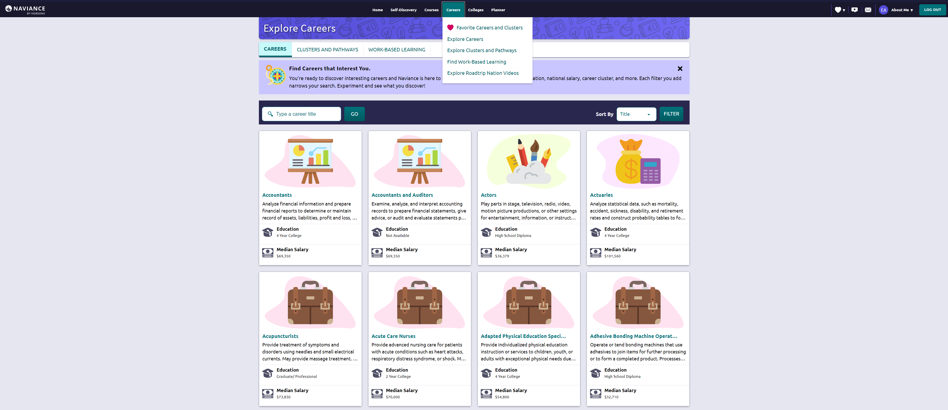

The Careers section does not have its own Home page. The image above is from the Explore Careers section, which gives you access to Careers, Clusters and Pathways, and Work-Based Learning. Use the Careers menu to access Favorites, find Work-Based Learning, and explore Roadtrip Nation videos. The options you see may vary based on the items that your school or district is using at this time.

* Clusters & Pathways: explore clusters (defines a focused group of related pathways and careers) and pathways (specific directions you can take within a cluster) to think about the careers that might be of most interest to you.
* Work-Based Learning: find meaningful, real-life experiences in Naviance Student to help support your college and career interests and goals after high school.
* Roadtrip Nation: a digital career exploration tool that enables you to access more than 8,000 video interviews chronicling the diverse personal stories of leaders who have turned their interests into their life’s work.

# Colleges Home

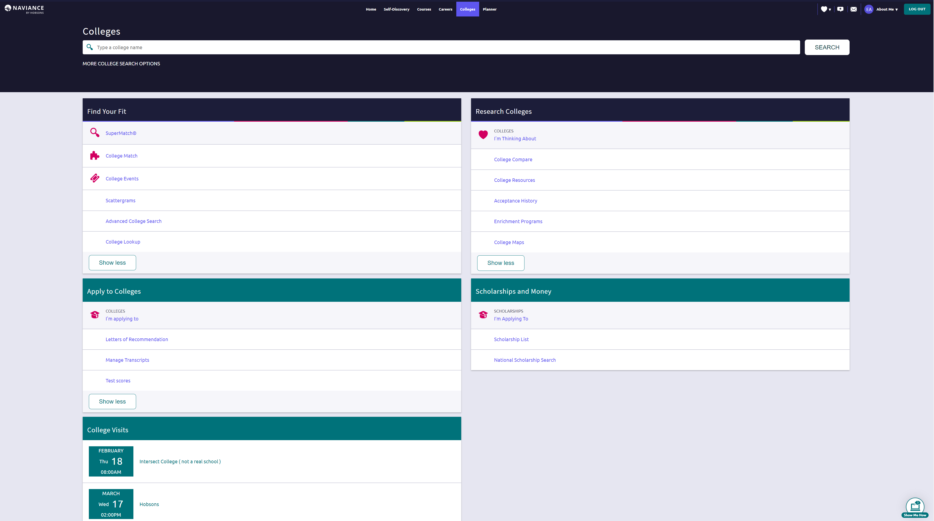

# Colleges Home

## Find Your Fit

SuperMatch™ College Search: Receive a list of best-fit schools based on criteria that you deem as important in your college search.

College Match: See and quickly favorite the other schools that students are applying to when they have also applied to a school from your favorites list. Additionally, check out other colleges that have accepted students with stats like your own.

College Events: View a list of colleges that are hosting events and sign up for those of interest.

Scattergrams: A graph used to help you analyze how you fit in with other students from your high school who have been accepted or denied admittance to a school based on GPA and test scores.

Advanced College Search: Using multiple categories, answer questions to identify colleges that match your interests and then save the search.

College Lookup: Lookup a school by multiple filters including name, country, state, or college group. Easily favorite colleges using the Heart icon found next to a school name.

## Research Colleges

Colleges I’m Thinking About: A list of schools that you have identified as prospects

College Compare: Add schools to compare the average GPA and test scores of students from your high school that have been accepted to that college during a time span.

College Resources: List of external web resources that may be valuable to your college search process.

Acceptance History: An alphabetical list of colleges where someone from your school has been accepted and/or enrolled over a time span.

College Maps: View an interactive map of schools based on a list of different pre-defined criteria. For example, you can see a map of the colleges from your Colleges I’m Thinking About list.

Enrichment Programs: Look for ways to get involved with your community and school, as well as possible internship opportunities and other events to build your experiences.

## Apply to Colleges

Colleges I’m Applying To: A list of schools to which you have decided to apply.

Letters of Recommendation: Request new and track existing letter of recommendation requests.

Manage Transcripts: Add and review transcript requests, as well as view associated fees.

Test Scores: View your key test scores, including SATs. Depending on school permissions, you may be able to add your own test scores.

## Scholarships and Money

Scholarships I’m Applying To: A list of scholarships to which you are applying.

Scholarship List: A list of potentially relevant scholarships that you can review and add to your applications list.

Scholarship Match: A list of scholarships that may be a suitable match for you based on scholarship requirements such as gender, ethnicity, GPA, etc.

National Scholarship Search: An external site hosted by Sallie Mae that provides a list of potential scholarship matches based on personal criteria as associated with Naviance Student.

## College Visits

View and enroll in (depending on permissions) college visits that are scheduled to occur either in-person or virtually.

# My Planner

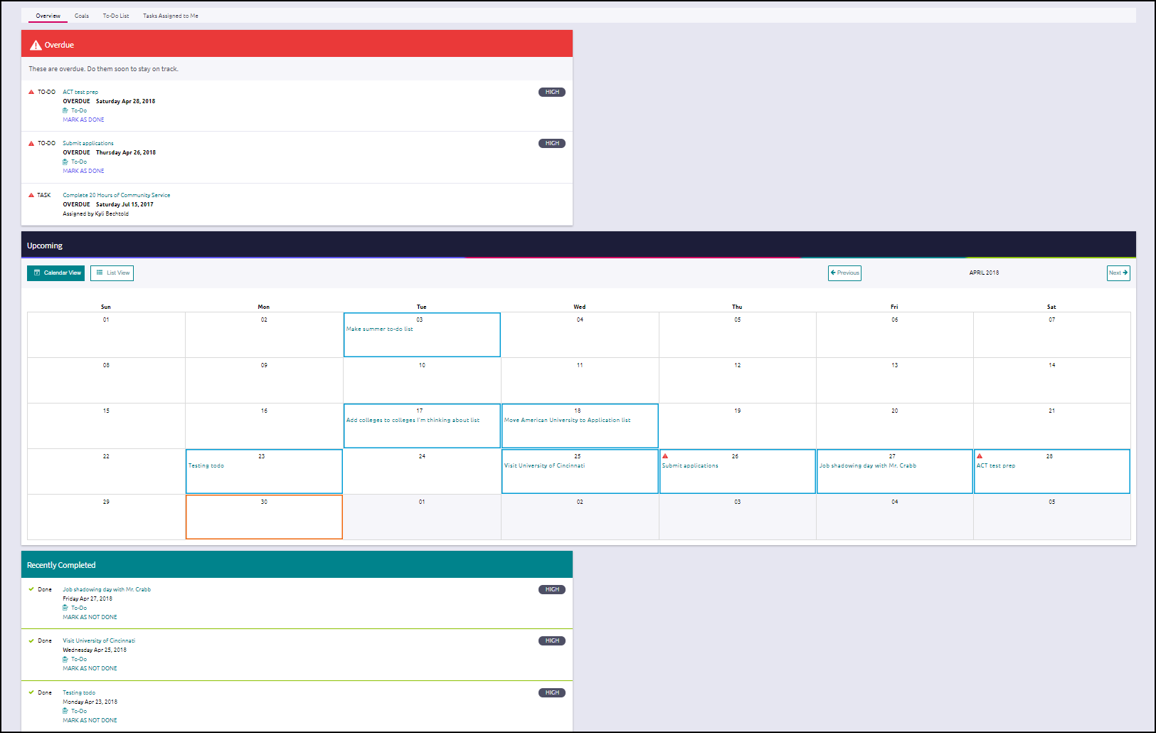

Switch between the Overview, Goals, the To-Do List and Tasks Assigned to you by your school.

Goals: Add your own goals about anything you are interested in achieving. Mark goals complete as you hit them.

To-Do List: Create a list of actions you need to complete.

Tasks Assigned to Me: Important tasks assigned to you by your school.

Use the Upcoming calendar to keep track of and open past and upcoming tasks and to-dos. Switch between the Calendar and List Views for a different visual of the events.

Overdue shows a list of tasks and to-do items that are overdue and should be completed as soon as possible.

Recently Completed is a list of the tasks and to-do items that you have recently marked as complete. You can use this location to view the items or change them to incomplete.

# About Me Home

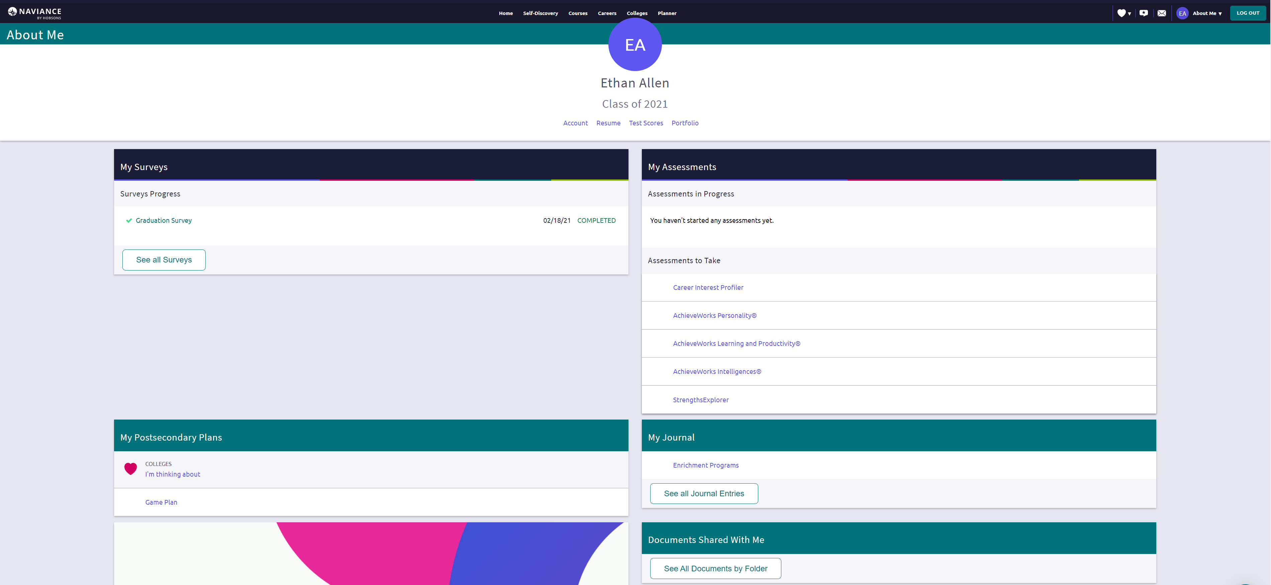

Colleges I’m Thinking About: A list of schools that you have identified as prospects.

Careers and Clusters I’m Thinking About: View the careers and clusters that you have added to your favorites.

Game Plan: If Game Plan displays under postsecondary plans, it is an indicator that your school would like you to fill out a survey about your plans beyond high school.

View and create journal entries for yourself or share them with counselors, teachers or your parents. You can use this area to journal about your experiences, your plans, your essays or anything you want. Documents can be attached to a journal entry.

About Me: View general Account information, build your Resume, view Test Scores, or view/print your full Naviance Student Portfolio.

Surveys in Progress: See a status indicator of the surveys you currently have in progress and need to complete.

Surveys to Take: See a list of surveys that your school would like you to complete. Click on a survey to get started.

View documents that a counselor or teacher has chosen to share *just* with you.

Assessments in Progress: See a status indicator of the assessments you are currently working on and need to complete.

Assessments to Take: See a list of assessments that your school would like you to complete. Click on an assessment to get started.