

## What Documents do I need to apply for ACE?

*Depending on your responses to application questions some or all the following documents may be required.*

**2024 Federal Tax Return Pages 1&2 (For applicants who are newly applying to ACE in the 25-26 school year):** Please submit pages 1&2 of the parent/legal guardians Federal Income Tax Return

* **Form 1040 Pages 1&2 and numbered Schedules (1&3)**

**Nontaxable Income Documents (If Applicable):**

* **2024 Social Security/Disability Income for parent/legal guardian & for all family members receiving benefits in the home (These documents must contain name that matches a name on the application, amount received & frequency)**
  + 2024 Form SSA-1099 Social Security Benefit Statement(s)
  + A letter from the Social Security Administration with the monthly social security benefits amount
* **2024 Child Support Income (It must contain the child and parent/legal guardian’s name)**
  + Court ordered legal documents
  + A letter from the provider of your child support income for 2024
  + A screenshot or print out of frequency & dates noted for the 2024 child support income of the online Customer Portal
  + Notarized letter with 2024 monthly child support income
* **2024 SNAP (Supplemental Nutrition Assistance Program) Income**
  + A screenshot or print out of the 2024 SNAP benefits income located under the case details of the online Customer Portal
  + Department of Children & Family Services (DCFS) letter with the 2024 monthly SNAP benefits income that includes the parent and child name
* **2024 TANF (Temporary assistance for needy families)**
  + Notice of benefit for 2024 from the appropriate agency
* **Housing Allowance (Military, Religious, Parsonage, etc.)**
  + Benefit statement, enrollment, or payment letter from specific agency
* **2024 Worker’s Compensation**
  + A worker’s compensation award letter

## How Do I Submit Documents?

Upon submitting your application, you will automatically be taken to your Application Summary page. There is a required document section that will list the document requirements specific to your application. You will also receive an email listing the required documentation. That email has a link to bring you directly back to your Application Summary page.

1. To upload documents, you can click on either the “**Upload your required documents**” hyperlink at the top of your page or the “**Upload**” button in the Required Documents section.

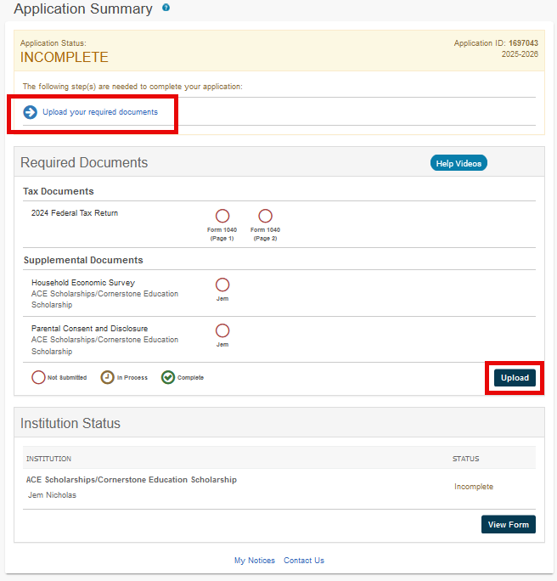

1. Once you have selected either option, the Upload Documents page appears listing out documents to upload. Select which document you are uploading in Step 1, then click “**Ready to Upload**.” Pay careful attention to the tips on the right-hand side.

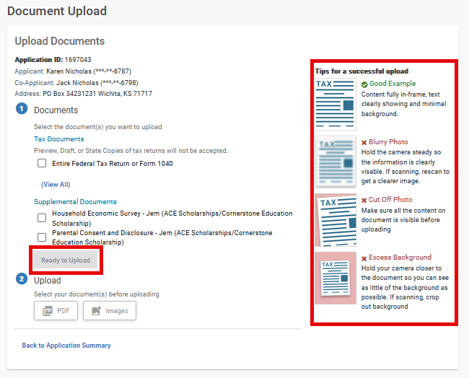

1. In Step 2, you can choose to upload either a PDF or an Image (JPEG) directly from your device. If you are choosing to upload an image, this image must be vertical, as horizontal images are not accepted. Once the image has been selected click the “Upload” button.

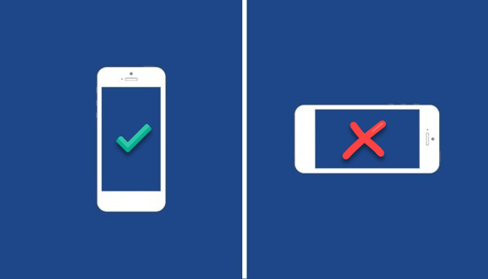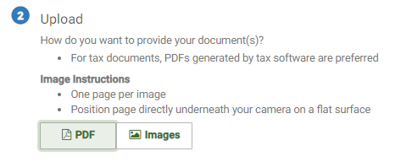

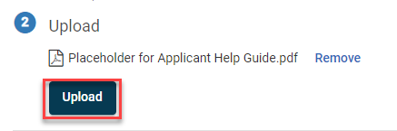

1. You will then receive a message once your document has been uploaded successfully. If you have additional documents to upload you can click “**Upload another Document**” and this will allow you to continue uploading documents to your application. An email confirmation that an upload has been made will also be generated to the email on file.

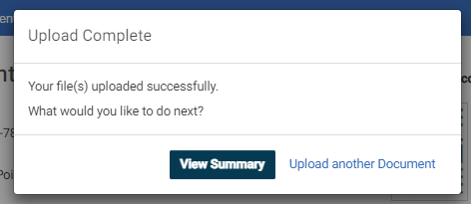

1. Once all documents have been uploaded and you have clicked the ‘**View Summary**’ button you will then land on the page below to see the document status updated. Please refer to the guide at the bottom for the document status.

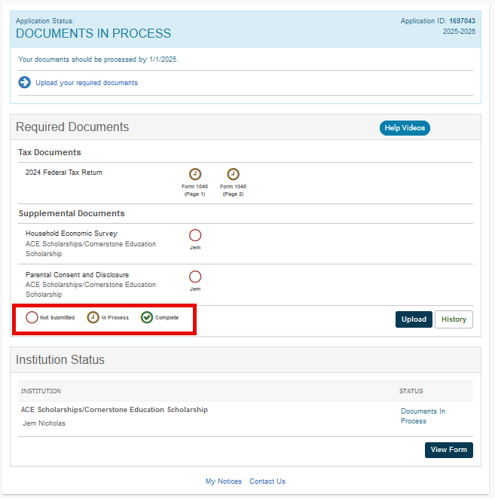

1. Please allow 10 business days for document processing. Once documents have been processed, you will receive a notification asking for additional documentation if there is an issue or a notice you are complete if everything has been received. If you have any questions, please contact the application helpline at 856-746-6521.