Cast Away

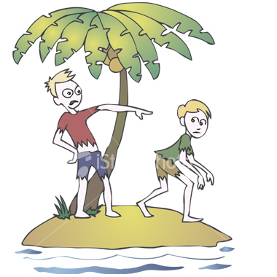

Directions: Imagine you experience a shipwreck in the South Pacific Ocean and become stranded on an uninhabited island. Create a government that will protect your people and preserve order. You and your fellow castaways must reach consensus on a Plan of Action. Be prepared to share with the class your thoughts related to the following matters:

1. How are decisions made?
2. How much power does the leader have?
3. How is the leader chosen/how does he or she become the leader?
4. How much input do average citizens have?
5. How will individual rights be protected?
6. How quickly are decisions made?
7. How efficient is the decision making process?
8. Would you describe your government as a monarchy, dictatorship or democracy?