Instructions for emailing students/parents from Aeries
- On the left panel within Aeries, expand Teacher Misc and select “Send Emails”
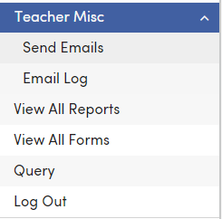
- Then click the Add Recipients button.
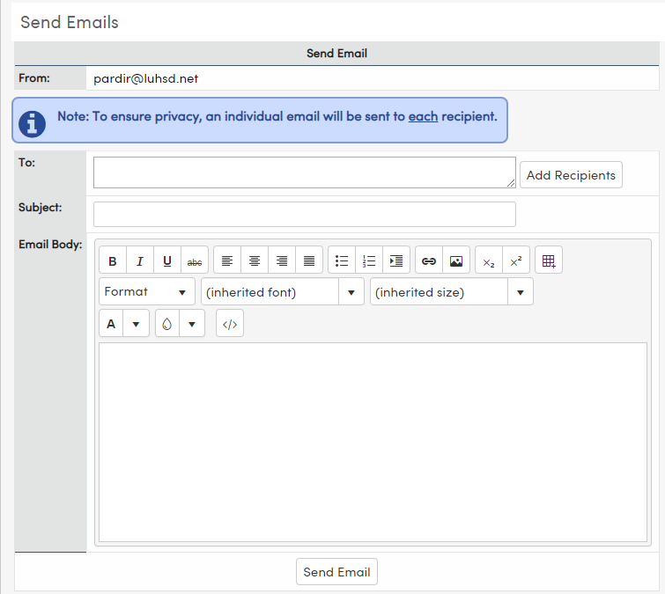
- Then choose one of the four options (student, period, class, or all of your students. (I have chosen “Class” which allows me to choose a specific class or multiple classes.
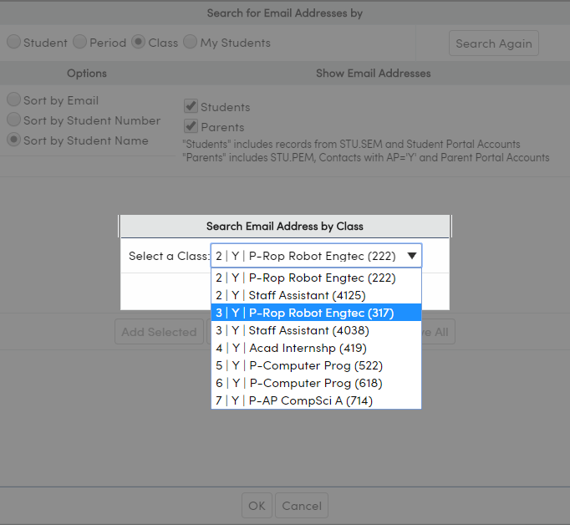
- Then select the “Add All” button which places all the email addresses to the bottom portion of the screen and then click the “OK” button.
- Construct your email and then press “Send Email” and that’s it.

