**Managing the retrieval of emailed student work within Outlook.**

1. Log into Office365 on your browser. (office.com or office.luhsd.net)
2. Open the Outlook application and move your mouse to the left pane where you’ll see (Favorites, Inbox, Sent Items…..) If those items don’t appear, click on the Toggle Left Pane button (three horizontal lines) next to the “New message” button.
3. Scroll down and within the “Cabinet” section you will see “New Folder”.
4. Single click on “New Folder” and type a unique name for your first class period. (i. e. Period 1)
5. Continue creating new folders for all your class periods.
6. I would also suggest you create subfolders within each class period folder in order to store each week’s assignments separately. (Right click on the “Period 1” folder, choose “Create new subfolder” and type for example: “Assignment 4/6-4/10”)

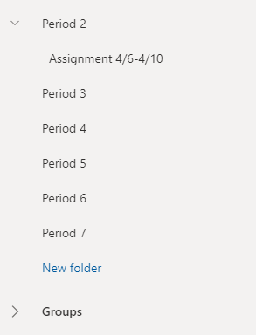

When it comes time to receive work from students, remind them to put their class period and assignment title in the subject line of their emails.

Upon receipt of student work, just drag and drop the email into the appropriate folder.