**Creating a test using Microsoft Forms**

Open your Microsoft Applications and choose Forms

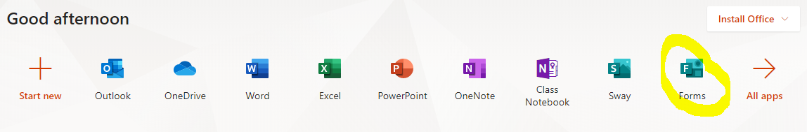

OR go to the 9 dots at the top of *any* Office 365 browser and choose Forms.

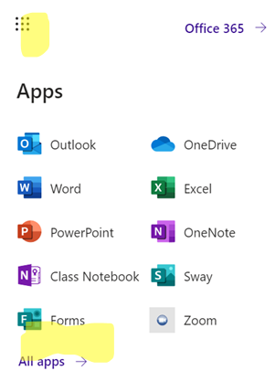

Choose New Quiz

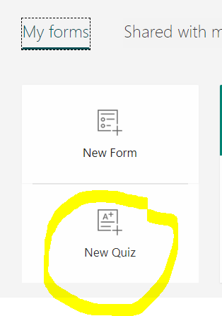

Next, you can name your quiz, write a description, add an image (see circled icon),and choose your question types.

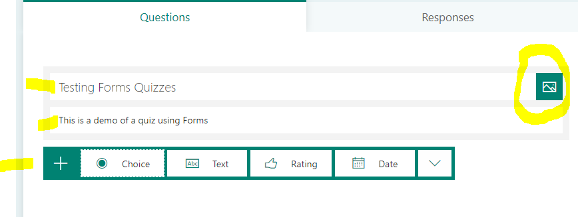

You can give each question a different point value:

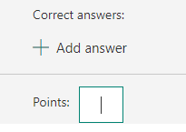

Students can upload files for their answers as well, and you can make different sections for your test:

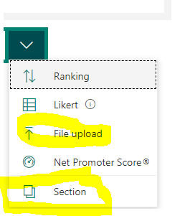

“Choice” questions give you the option for writing a correct answer, making the question required, and making a long question:

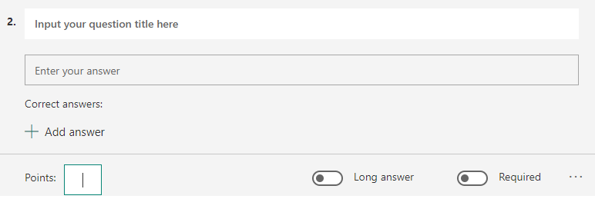

The three dots at the bottom right allow you to automatically shuffle multiple choice answers. The “Math” option allows for subscripts, superscripts, and a variety of math and science symbols. The “multiple answers” at the bottom lets you select multiple correct options for multiple choice problems.

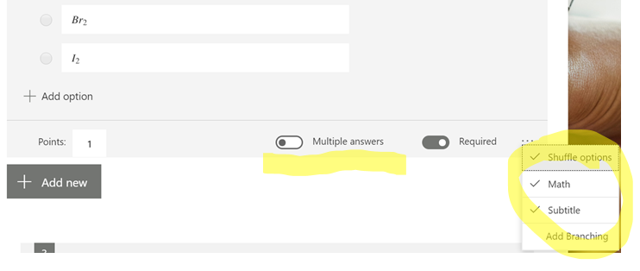

The picture button next to the question allows you to insert a picture just for that specific question.

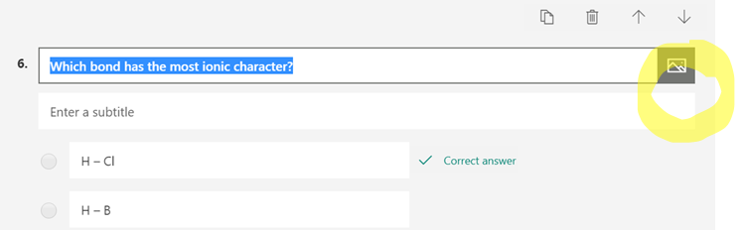

The arrows at the top of the question let you move questions around on your quiz:

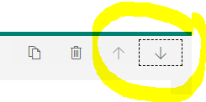

The “Theme” button gives you choices for backgrounds:

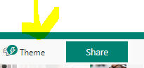

Using the Share button, you can share this quiz with students on your website, on Remind 101, or by email. You can also share the template with colleagues, who can edit the test as their own:

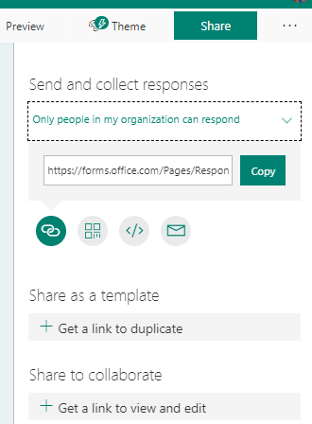

If you select the three dots at the top right of the screen, then choose settings, you can decide whether you want students to see their results AND the correct answers right after finishing their quiz.

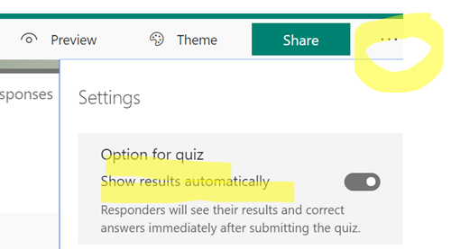

You can also decide whether you want to make students log in to their account before answering (

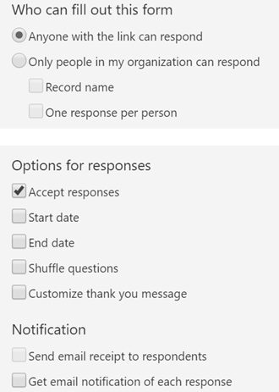

The Response tab give you the scores and responses:

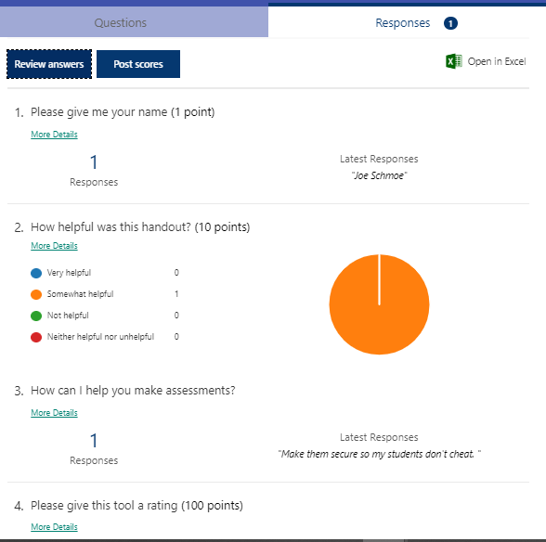

The Review Tab gives you the platform to score responses, give feedback, and see how long students took to answer each question:

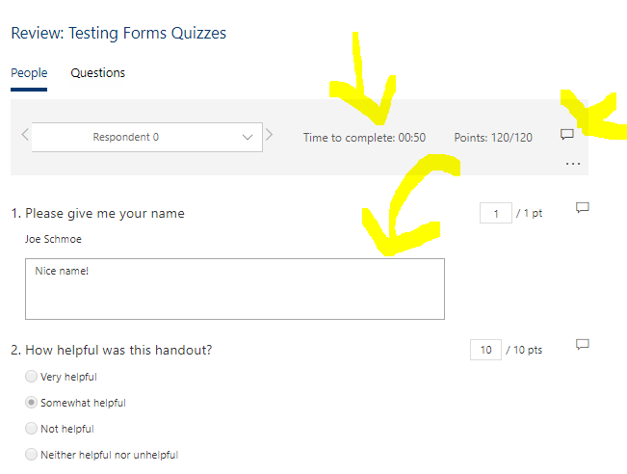

You can post scores and get a list of how student scored:

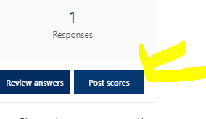

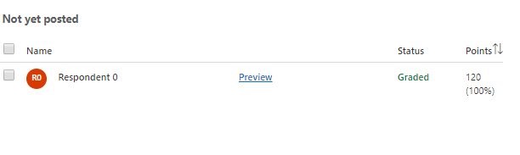

You can also download the responses and scores into excel—this will also give you their total scores.

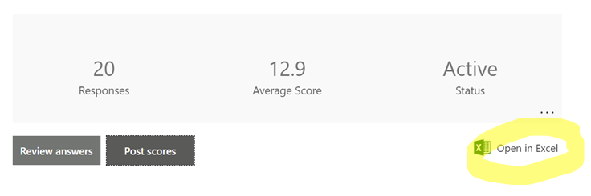

*Pro tip—if you make one of the questions be their student ID, you can upload their scores directly into Aeries!*

Here’s a demo test I made for you to try:

[Demo Quiz](https://forms.office.com/Pages/ResponsePage.aspx?id=bsSeXYwVl0uXor1txqc9IqSzZeX4O8dIheOXm33E2c1UQks3QTE2SU4xRDBMUUs1QThaNjA4Q1UxOS4u)