**How to Host a Zoom Meeting With Students**

**Setting up a meeting with your class:**

1. **Log into office.luhsd.net**
2. **Find the Zoom App and open it. (Zoom will be under the “All Apps” section)**

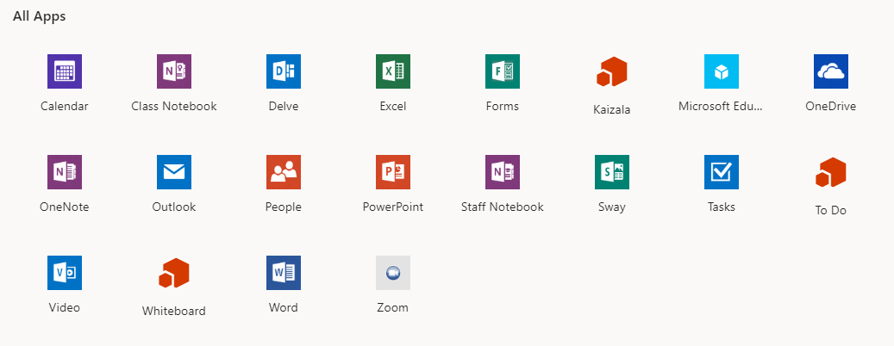

1. **Click on the “Sign in” button (Your account has already been activated)**

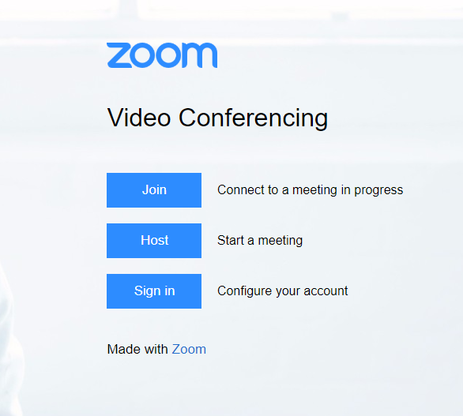

1. **Select “Meetings” from the left panel and then “Schedule a New Meeting”.**

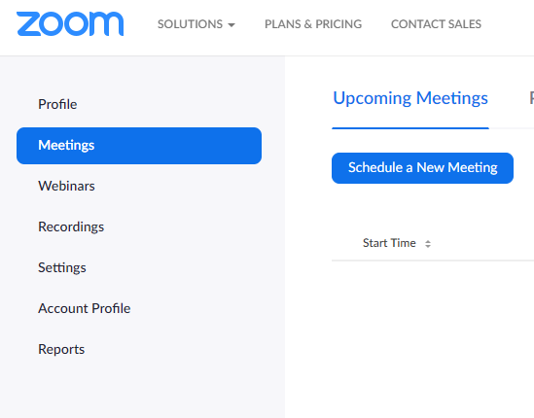

1. **Complete the “Schedule a Meeting Form” (I chose to turn on Host and Participant Video, turned off “Join before host” and made sure “Enable waiting room” was turned on.) then click “Save”.**

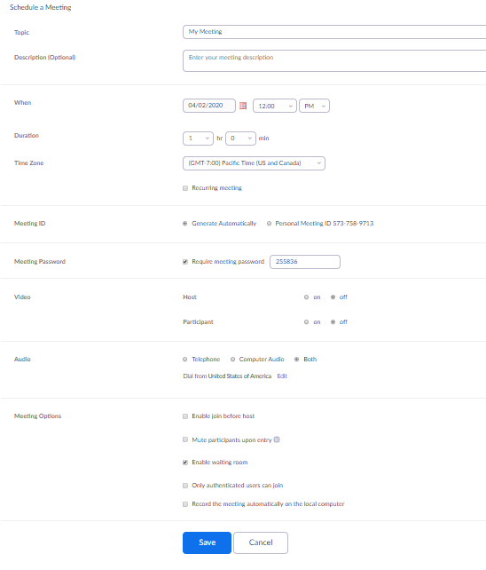

1. **On the confirmation page click “Copy the invitation”**

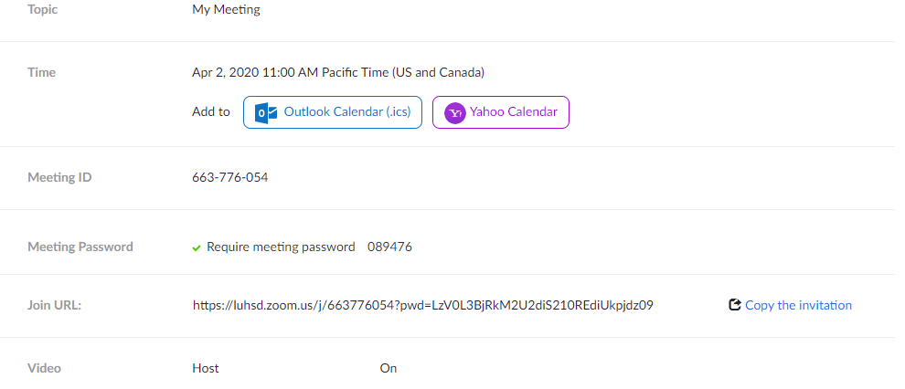

1. **On the Copy Meeting Information Screen click Copy Meeting invitation button which includes the link for students to join the meeting as well as the Meeting ID and password.**

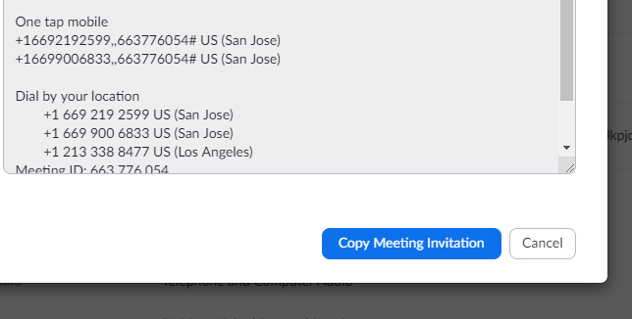

1. **You will see a confirmation that a copy was saved to your computer’s clipboard.**
2. **Paste the meeting invitation into the body of an email that you send to your students through Aeries or if you already use Remind with your students you can use that to notify them of the meeting ID and password of your meeting. (I would not post meeting ID’s and passwords on your webpages.)**

**Hosting the meeting:**

1. **Log into Office365**
2. **Open the Zoom App**
3. **Click on the Sign in/Account button**
4. **Find your scheduled meeting and click “Start”.**

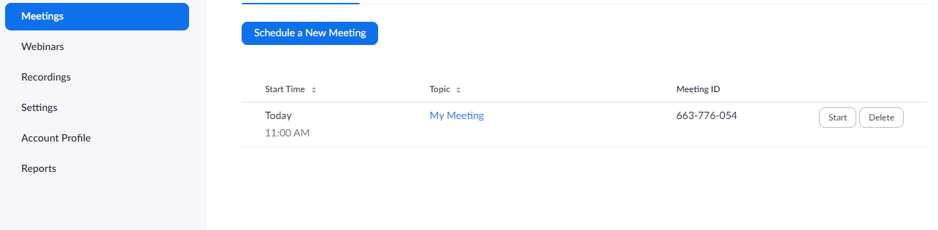

**Here’s a link for the controls available to you to host a meeting:**

[**https://support.zoom.us/hc/en-us/articles/201362603-Host-and-Co-Host-Controls-in-a-Meeting**](https://support.zoom.us/hc/en-us/articles/201362603-Host-and-Co-Host-Controls-in-a-Meeting)