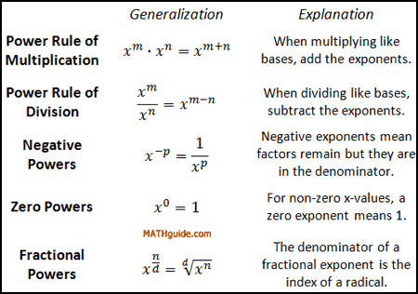

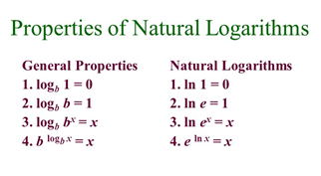
Power to a Power
(X²)³ = X² * X² * X² = X⁶

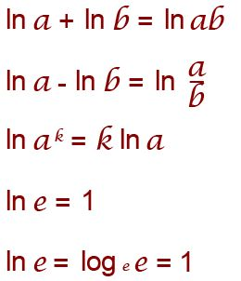

Similar Powers
(18)³ = 2³ * 9³ = 3³ * 6³ = 5832
e^{x} =7
Ln e^{x} = ln 7
xlog_{e}e = ln 7 (log_{e}e = 1)
x = ln 7
Log_{e}35 = A
x= 1.9459
Ln35 = A

log₂(8)=X
2^{X}=8
2^{X}=2³
X=3

log₂(x) + log₂(x – 2) = 3
log₂[(x)(x – 2)] = 3
log₂(x² – 2x) = 3
2³ = x² – 2x
8 = x² – 2x
0 = x² – 2x – 8
0 = (x – 4)(x + 2)
x = 4, –2

log₂ (5x + 7) = 5
5x + 7 = 2⁵
5x + 7 = 32
x = 5

ln(4x -1) = 3
4x -1 = e³
4x -1 ≈ 20.085537
x ≈ 5.271384

log₃ (9x + 2) = 4
9x + 2 = 3⁴
9x + 2 = 81
X=79/ 9

Log₁₀(5x -11) = 2
5X - 11 =10²
5X - 11 =100
X = 111 / 5

Log₄ x + log₄ (x -12) = 3
Log₄ (x(x -12)) = 3
x(x -12) = 4³
x² -12x = 64
x² -12x - 64 =0
(X + 4)(X-16) = 0
x=- 4 or x= 16
x= 16 cannot be negative

Log₂(X + 1) - Log₂(X – 4) = 3
Log₂((X + 1) / (X – 4)) = 3
(X + 1) / (X – 4) = 2³
(X + 1) / (X – 4) = 8
X + 1 = 8(X – 4)
X + 1 = 8X - 32
X = 33 / 7

Log₆ (x + 4) + log₆ (x - 2) = log₆ (4x)
Log₆ ((x + 4)(x - 2)) = log₆ (4x)
(x + 4)(x - 2) = 4x
x² + 2x - 8 = 4x
x² - 2x - 8 = 0
(x + 2)(x - 4) = 0
X = -2 or x = 4 cannot be negative

