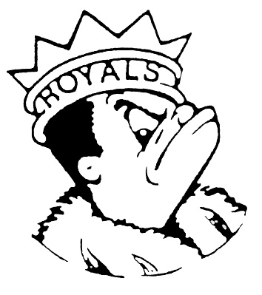
FRIDAY
FEBRUARY 17, 2023
Morning Announcements

- Today is All About Cheese! Mozzarella Sticks w/Marinara OR Grilled Cheese Sandwich. Don't forget to choose a fruit, juice, vegetable or a milk to complete your meal.
- Yearbooks will be on sale this week on TODAY in the cafeteria. February 24th is the last day to pre-purchase and guarantee you get a 2023 yearbook. Stop by and visit the yearbook staff in the commons during your lunch to purchase your yearbook and to learn about our new digital feature. Yearbooks are $50!
- Why did the baker's card get declined? He didn't have enough dough! Luckily the tickets for the Larkin Loafs improv team are only $5, come and support your fellow Royals TONIGHT for a fun time. Shows are at 5:30 and 7pm, see you there!
- If you missed the auditions for the Talent Showcase, you may still be able to audition. Information can be found on the Drama Website to submit a video audition, or email Mr. Baxter about auditioning in person.
- The Library is closed TODAY.

Royal Congratulations

And Remember Royals,
LIVE, LOVE LARKIN!

