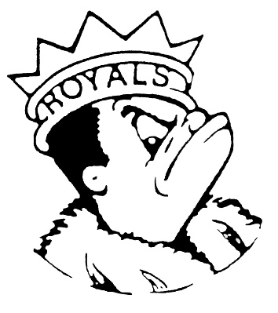
THURSDAY
May 18, 2023
Morning Announcements

- Today is Which ‘Wich! Hot Ham & Cheese Croissant OR Veg n Cheese Stuffed Sandwich.
- Today is “T” for Twin Day and tomorrow is “U” for USA Day.
- Open swim TODAY from 3-4pm at Larkin Aquatic Center. Come and enjoy.
- Next Monday come celebrate the end of the year with GSA in Room E196. See you there.

Royal Congratulations

And Remember Royals,
LIVE, LOVE LARKIN!

