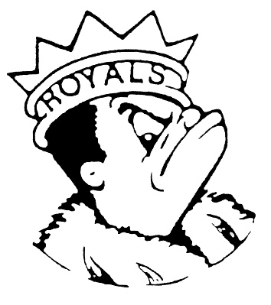
FRIDAY
September 1, 2023
Morning Announcements

- Today Beef Hot Dog OR Garlic French Bread.
- First Open Swim of the year! Come and enjoy our beautiful pool, TODAY at 3pm. Bring your friends.
- Come join Crossroads for our first meeting of the year on Wednesday, September 6th at 7am inA14 (off the Main Office hallway) for fellowship, Bible study, and prayer. All are welcome, and hope to see you there!
- DECA! DECA! DECA! If business is your thing, don’t miss the opportunity to participate in the LHS Chapter of DECA! We meet on Tuesday’s in Room D67 at 3pm. Everyone is welcome! Our first official meeting is Tuesday, September 5th! Hope to see you there!
- Attention Students and Staff: Don't miss out on a chance to purchase your Homecoming 2023 T-shirt. Check your email after 1st Period today for the link to the Online Store. https://stores.inksoft.com/LHSHOCO/shop/homeEach shirt is available in either Short Sleeved or Long Sleeved Options. Orders must be completed by Friday, September 8 to insure all T-shirts are available for Homecoming Week which is September 25-September 30. Additional information regarding this year's events will be coming next week. This year's theme revolves around Children's TV Networks.

Royal Congratulations

- Boys Varsity Soccer remains undefeated after 5 matches beating Lake Park High School 2-1 to kick off the Huntley Quad Tournament last night. One goal each scored by Fran Montoya and Adrian Diaz. Adrian Diaz also had an assist. Tremendous goalkeeping from Danny Duarte to keep us in the match. Varsity Boys Soccer will play two more games at Huntley; GOOD LUCK.
- Last night the Varsity Boys Soccer Team beat Glenbard East 1-0 in their first conference match of the season! Goal scored by Adrian Diaz with an assist from Chris Tellez. Tremendous effort on defense from Fran Montoya and Danny Duarte to keep the opponents scoreless. The next match is later today to kick off the Huntley Quad Tournament, with games Friday and Saturday as well. Keep up the great work!
- Congratulations Royal Orcas on another wonderful meet! Keep up the good work.

And Remember Royals,
LIVE, LOVE LARKIN!

