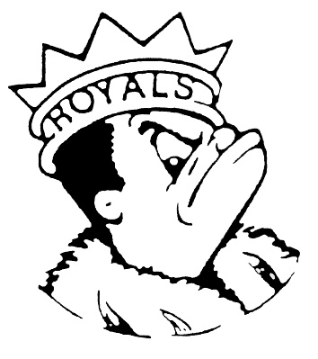
TUESDAY
October 31, 2023
Morning Announcements

- Today is Chicken Tenders OR Plant Based Nuggets w/Cheese and a grain.
- Picture Retake Day is tomorrow in the Concession Stand. If you do not take a picture you will not be in the yearbook. Please stop by during your study hall, if you have one, or your lunch hour.

Royal Congratulations

And Remember Royals,
LIVE, LOVE LARKIN!

