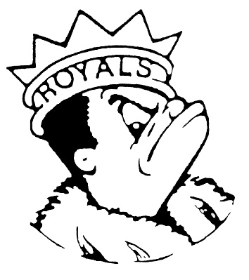
FRIDAY
December 8, 2023
Morning Announcements

- Today is Turkey Pizza Pocket OR Mini Cheese Pizza Pockets.
- Best Buddies is cancelled for December 11th and is rescheduled for December 18th.
- Last night, Larkin hosted many events, and one was a math meet. Our junior team tied for second place at our site and in our division. Way to go math team! You can still join us after school on Wednesdays in B209. See you there!
- Juniors, please join us for a junior class meeting in A14 at 3pm TODAY.
- Calling all actors and musicians! Auditions for the Group Interpretation production of Carrie by Stephen King are taking place on Monday, December 11th after school in the Black Box. Sign up for an audition time slot and fill out the audition form prior to your audition. All information can be found on the Group Interp website (tinyurl/com/LARKINGI). See Mrs. Weihofen with any questions.
Royal Congratulations

And Remember Royals,
LIVE, LOVE LARKIN!

