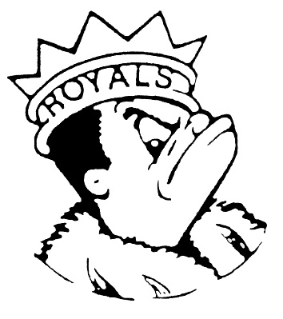
MONDAY
December 11, 2023
Morning Announcements

- Today is Chicken Patty OR Cheese Pizza Bagels.
- Best Buddies is cancelled for TODAY and is rescheduled for December 18th.
- Girls Track workout is canceled for TODAY.
- Please join us to support the junior and senior class to raise money for prom. Hot Chocolate for sale during lunch hours in the commons on Thursday. $2 a cup, $3 if you like toppings.
- Have you applied to college yet? Found scholarships? Come join us at Life After Larkin Club in the library tomorrow and get guidance on your plans for the future.
- Calling all actors and musicians! Auditions for the Group Interpretation production of Carrie by Stephen King are taking place TODAY after school in the Black Box. Sign up for an audition time slot and fill out the audition form prior to your audition. All information can be found on the Group Interp website (tinyurl/com/LARKINGI). See Mrs. Weihofen with any questions.
- Royalstyle Victories earned this past Saturday as Senior, Josh Castillo, grasped a 4th Place Medal at the 16 Team Buffalo Grove Rex Lewis Invitational and Junior, Ashley Hammond grasped a 4th Place Medal at the 16 Team Maine East Mejo Hernandez Invitational. This is Ashley's third consecutive top 4 podium appearance. Congratulations to both. Varsity Boys and Varsity Girls placed 8th Overall in their respective Invitational. Next up: the Tomcats of East Aurora at EAHS, Wednesday Night. ON THE MAT IS WHERE IT'S AT!
- Congratulations to the Royal Speech Team on their 5th place win at the highly competitive Rochelle tournament this past Saturday. Elliot McGowan was the novice champion in Original Comedy, and Quinn Dadabo was the novice champion in Impromptu Speaking. See the Royal Congratulations for the complete list of winners. Currently, the team has racked up 114 individual awards this season and we're only halfway through!

Royal Congratulations
VARSITY FINAL RESULTS
4th place in Original Oratory - Aiden Weeks
5th place in Dramatic Duet Acting - Lucy Akemann and LJ Roller
6th place in Dramatic Duet Acting - Jake Boucher-Merlo and Leesa Starin
6th place in Dramatic Interpretation - Nadia Schultz
NEXT-IN FINAL RESULTS
4th place in Humorous Duet Acting - Jake Boucher-Merlo and LJ Roller
4th place in Special Occasion Speaking - Elliot McGowan
6th place in Extemporaneous Speaking - Lara Amaro
6th place in Humorous Duet Acting - Lucy Akemann and Sophia Adkins-Baturin
NOVICE FINAL RESULTS
Tournament Champion in Impromptu Speaking - Quinn Dadabo
Tournament Champion in Original Comedy - Elliot McGowan
3rd place in Extemporaneous Speaking - Nadia Schultz
3rd place in Humorous Interpretation - Quinn Dadabo
3rd place in Oratorical Declamation - Hannah Castro
4th place in Dramatic Interpretation - Elliot McGowan
4th place in Informative Speaking - Atziry Serna
5th place in Dramatic Interpretation - Scottie Campbell
6th place in Original Comedy - Lucy Akemann

And Remember Royals,
LIVE, LOVE LARKIN!

