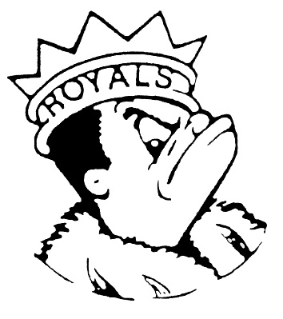
WEDNESDAY
January 10, 2024
Morning Announcements

- Today is Grilled Cheese OR Cobb Salad.
- The Junior and Senior meetings have been rescheduled for next Tuesday, January 16th. Seniors will be in A14 and Juniors in A15.
- Boys’ track begins next week. There will be an informational meeting TODAY after school on the basement track at 3:05pm
- Girls Track will have an information meeting TODAY from 3-3:30pm in room B110. Please plan to attend if you are going to join the team this year. See Coach Carey, Coach Lauesen, or Coach Ray if you cannot attend this meeting.
- If you are interested in joining the esports team, meet us in D67, 3:10-4:40pm on Mondays and Thursdays. The first practice is this Thursday, see you there!
- Larkin creative writers. Mr. Pierce is collecting submissions for the 2024 Upstate Literary Festival in Bartlett. Students may submit short stories, poetry, slam poetry performances, descriptive sketches, personal essays, and plays. If your submission is accepted, you will be eligible for the field trip to Bartlett on April 5th. All submissions are due January 2th. Please contact Mr. Pierce in the English department for more info.

Royal Congratulations
Congratulations to the Royal Speech Team on their 8th place finish at the highly competitive Thornton tournament this past weekend. Leesa Starin and Jake Boucher-Merlo were the Next-In Tournament Champions in Dramatic Duet Acting and Scottie Campbell was the Top Novice in Dramatic Interpretation.

VARSITY FINAL RESULTS
2nd place in Extemporaneous Speaking - Lara Amaro
5th place in Humorous Duet Acting - Lucy Akemann and Sophia Adkins-Baturin
NEXT-IN FINAL RESULTS
Tournament Champions in Dramatic Duet Acting - Jake Boucher-Merlo and Leesa Starin
2nd place in Original Oratory - Aiden Weeks
3rd place in Dramatic Duet Acting - Sophia Adkins-Baturin and Fatima Esteban
3rd place in Impromptu Speaking - Aiden Weeks
4th place in Dramatic Interpretation - Leesa Starin
5th place in Original Comedy - Lucy Akemann
6th place in Humorous Duet Acting - LJ Roller and Jake Boucher-Merlo
6th place in Special Occasion Speaking - Adunni Okiji
7th place in Original Oratory - Lara Amaro
TOP NOVICE RESULTS
Dramatic Interpretation - Scottie Campbell

And Remember Royals,
LIVE, LOVE LARKIN!

