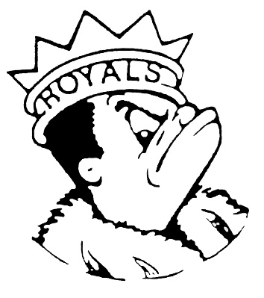
MONDAY
January 22, 2024
Morning Announcements

- Today is Popcorn Chicken OR Yogurt & String Cheese.
- Auditions for the Talent Showcase are after school TODAY or Wednesday in the Auditorium. Sign up at the auditions or on the sheet located outside the Black Box. See Mr. Baxter for more information.
- Any ladies interested in coming out for Badminton this Championship Season, there will be a required pre-season meeting on Thursday, January 25th in Room F305 at 3pm. Questions, email Coach Danan.
- Do you want to get to know that this year’s yearbook is all about? Would you like to get your yearbook personalized? Well, Larkin’s yearbook staff is doing an in-person informational book and pre-sale this week. The Final day to order a yearbook with personalizations is Friday, January 26th.
- Softball will be having a mandatory meeting on Wednesday, January 24tha t 3:10pm on A20.
- Girls track has started. Please join us this season. Be sure to get your physical on file and get registered on 8to18 ASAP. See Coach Carey, Lauesen or Ray with questions.
- Congratulations to the new Peer Leaders for 2024. If you applied and didn’t receive an email, please contact Mrs. Pavoris or Mrs. Carey. Our first meeting is on February 24th.
Royal Congratulations
- This past Saturday, the Royal Speech Team hosted the Taylor Swift Eras Tour-nament right here at Larkin! Mrs. Weihofen and the team would like to sincerely thank the staff and students that helped make the day a huge success. The team sent 15 entries to finals and Aiden Weeks was the Next-In Champion of Original Oratory. With these awards, the team has now surpassed 200 individual awards won this season. Cheer on the team as they head to Conference at Streamwood this weekend.

- VARSITY FINAL RESULTS
2nd place in Dramatic Duet Acting - Jake Boucher-Merlo and Leesa Starin
2nd place in Humorous Duet Acting - Lucy Akemann and Sophia Adkins-Baturin
3rd place in Impromptu Speaking - Abby Walker
4th place in Poetry Reading - Leesa Starin
5th place in Humorous Duet Acting - Elliot McGowan and Fatima Esteban
5th place in Dramatic Duet Acting - Lucy Akemann and LJ Roller
6th place in Original Comedy - Elliot McGowan
6th place in Extemporaneous Speaking - Lara Amaro
7th place in Dramatic Duet Acting - Sophia Adkins-Baturin and Fatima Esteban
- NEXT-IN FINAL RESULTS
Tournament Champion in Original Oratory - Aiden Weeks
2nd place in Impromptu Speaking - Aiden Weeks
2nd place in Special Occasion Speaking - Elliot McGowan
4th place in Extemporaneous Speaking - Hannah Castro
5th place in Poetry Reading - Jake Boucher-Merlo
5th place in Informative Speaking - LJ Roller
- A Royalstyle Victory for our Wrestling Teams. Varsity Boys medaled 3 at the Upstate Eight Conference Championship Finals this past weekend.
  - Salvador Garcia placed 3rd
  - Damari Miller placed 4th (Now 2x Varsity All-Conference)
  - Reili Carrato placed 5th
Varsity Girls medaled 10 at the Upstate Eight Conference Championship Finals and Placed 2nd Overall in Team standings - just 26 points shy of East Aurora.
- 2nd Place Winners are Susan Cruz, Ashley Hammond, Melanie Granda, Mia Reyes, & Kim Reyes
  - 3rd Place Winners are Zamaya Taylor, Jade Caballero-Flores, & Milly Reyes
  - 4th Place Won by Tina Ebrahimi &
  - 5th Place won by Stephanie Smith
Congratulations to ALL
  - Next Up IHSA Regional Championship Finals for Varsity Girls this weekend on the 26th & 27th.
  - Upstate Eight Conference for JV & Frosh Boys this Saturday on the 27th
  - Varsity Boys IHSA Regional Championship Finals on Sat February 3rd.

ON THE MAT IS WHERE IT'S AT .... LET'S WRESTLE!

And Remember Royals,
LIVE, LOVE LARKIN!

