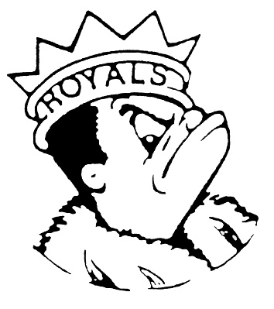
THURSDAY
February 8, 2024
Morning Announcements

- Today is Loaded Nachos OR Bean and Cheese Burrito.
- Good Morning, I am Omarion Castey Class of 2024. I am a member of the BSU and as you may know, TODAY is the 8th day of the Black History Month. I want to talk about the colors of Black History Month as they signify our identity and culture. The colors are black, red, yellow and green and each and every color has a different meaning behind it with black standing for resilience, read being the blood that runs through our bodies, yellow standing for the optimism and justice, and green meaning for the land and rich greenery. These colors each have a significant meaning, influence, and impact of my culture. I am proud to know what they represent and represent them everyday and I hope you guys leaned something today as well. Thanks for listening and have a good day.
- In Boys Tennis, Preseason workouts are TODAY from 3-4pm. Bring your racket, gym shoes, water bottle, and snack. Meet in E199.
- HOSA will be selling Valentine’s Teddy Bear Key Chains Monday, Tuesday and Wednesday of next week. Stop by the table during your lunch periods and buy one for only $3.
- A big congratulations to AVID Senior, Rachel Albert, who has been accepted to Bradley University, Loyola University, University of Minnesota and Aurora University. In total, Rachel has earned $176,000 dollars in tuition reduction!! Congratulations Rachel!
- Do you want to learn about a new and growing sport in Illinois? Do you want to be a part of a team and make new friends at other schools? Have you ever heard of Lacrosse? We are looking for girls interested in joining a team sport, no equipment or experience required! We will teach you all you need to know to be a part of this great program. Our open gym is TONIGHT from 7:30-8:30 pm however it is being held at Streamwood High school so you will have to coordinate your own ride over. If you are interested you can also contact Mx. Miller in the Art Department for more information.

Royal Congratulations

And Remember Royals,
LIVE, LOVE LARKIN!

