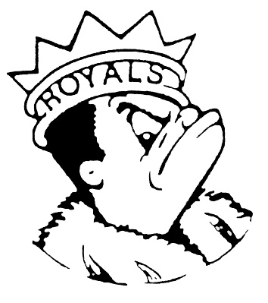
FRIDAY
February 9, 2024
Morning Announcements

- Today is Cheese, Pepperoni Or Buffalo Chicken Pizza.
- HOSA will be selling Valentine’s Teddy Bear Key Chains Monday, Tuesday and Wednesday of next week. Stop by the table during your lunch periods and buy one for only $3.
- Girls track registration ends February 16th. Sign up, get your physical and join us. Girls in a winter sport, see Coach Carey, Lauesen or Ray for start dates.
- In wrestling, Today is the start of the IHSA Wrestling Sectional Championship Finals. Let's wish the following wrestlers their best performance, as they are one step away from advancing to the State Finals. In the womens: Ashley Hammond, Tina Ebrahimi, Kim Reyes, & Susan Cruz. In the mens: Damari Miller, Gabriel Requena, Josh Castillo, & Reli Carreto. ON THE MAT IS WHERE IT'S AT! LET'S WRESTLE.
- Hello Royals! Key Club is looking for donation items to give to the people in need. Help your community by donating new or in good condition items in urgent need like:
- Men’s or women’s jeans, sweats, hoodies, long sleeves, short sleeves, jackets in any size,
- Traveled size hygienic products
- Tooth brushes
- Sports bras &-
- Men’s boxer briefs
We are also looking for other donations like:
- Adult backpacks
- Adult size towels &
- Cases of water
There will be drop off boxes next Monday in room E299 and the main office. Donations will go from Monday through March 8th. Thank you

Royal Congratulations

And Remember Royals,
LIVE, LOVE LARKIN!

