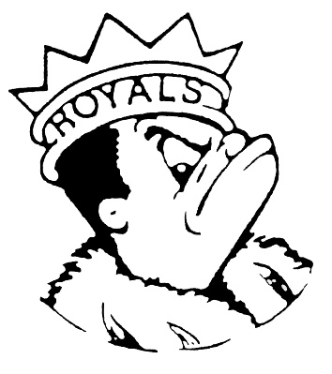
FRIDAY
February 23, 2024
Morning Announcements

- Today is Turkey Pizza Pocket OR Mini Cheese Pizza Pockets.
- This is the last week to pre-order your yearbook. Go to Jostens.com to order yours today. Pre-ordering is the only way to guarantee you get your book. Price is $50 for pre-order and $60 after TODAY. The yearbook staff will be in the commons TODAY to answer your questions.
- Interested in girl’s softball? Tryouts start Monday, February 26th from 5-7pm in the upstairs North Gym. Please register ASAP on Larkin’s Website and bring any equipment you have. If you have questions, please see Ms. Johnson in the Social Studies Office.
- Baseball tryouts will be held next week Monday through Wednesday. You must be registered and have a current physical to be able to tryout. Contact Coach Morado with any questions.
- Do you like being active? Do you like learning a new sport? Do you want to meet new people? Then come and join LHS’s new Pickleball Club! Pickleball Club will meet every Wednesday in Room F317 after school starting 2/28. To find out more information, scan one of our posters or come on down to F317 or F301 and talk to Mrs. Brannon or Mrs. Watts! Hope to see you on the court.
- The Royals scored a second-place finish in a four-team indoor track meet at Rolling Meadows last night. Larkin was led by senior Jaydis Frazier who won both the 55- and 200-meter dashes. Frazier teamed up with Gael Almanza, Galvin Peterson, and Matt Steffen to take second in the 4-lap relay. Meanwhile, distance runners Alex Lopez, Xavier Deleon, David Lawson, and Rafael Valdez teamed up to win both the two-mile relay and the mile relay. It’s not too late to come out for boys’ track. Find Coach Borczak for information.
- A big congratulations to AVID senior, Alan Garcia, who has been accepted to Loyola, University of St Francis, NIU, Arizona State, University of Louisville, University of Arizona, UIC, and University of Kentucky. In total, Alan has earned $148,000 dollars in tuition reduction!!! Congrats, Alan!

Royal Congratulations

And Remember Royals,
LIVE, LOVE LARKIN!

