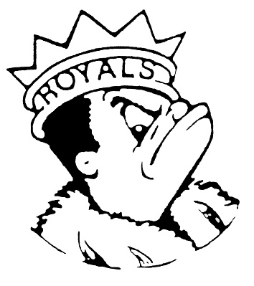
WEDNESDAY
March 13, 2024
Morning Announcements

- Today is BBQ Grilled Chicken Sandwich OR Cheese Quesadilla.
- Attention Students taking the Seal of Biliteracy Test: TODAY students with last names L-Z are to report to the library 1st period.
- FREE TUTORING AND FREE SNACK ~ Come to the library after school, Mondays through Thursdays from 3:00-4:30pm. We offer free tutoring and then you can take a break for a free snack in the Commons. Feed your mind and body at the 9th Period Royal Academic HUB.
- Did you order your Women’s History Month Shirt? Your orders will be delivered as they arrive, please check for a U-46 email in the following two weeks for delivery update.

Royal Congratulations

And Remember Royals,
LIVE, LOVE LARKIN!

