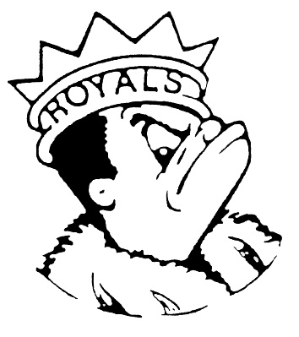
FRIDAY
MAY 10, 2024
Morning Announcements

- Today is Cheese Pizza OR Pepperoni Pizza.
- The official Senior Countdown ~ Today is P for pinkalicious day (wear all pink). Monday is Queens and Kings Day.
- The boys track team had a few all-conference top 3 performances last night at Memorial Field. Leading the way was senior Trenton Lewis who was 2nd in the 110-meter-high hurdles and 3rd in the 300-meter intermediate hurdles. Jon Wells was 6th in the high hurdles and TJ Boone was 4th in the intermediate hurdles. Senior Michael Barton was an all-conference selection, taking 3rd in the triple jump. Senior Tramare Reed was 4th in both the triple jump and the high jump.

And Remember Royals,
LIVE, LOVE LARKIN!

