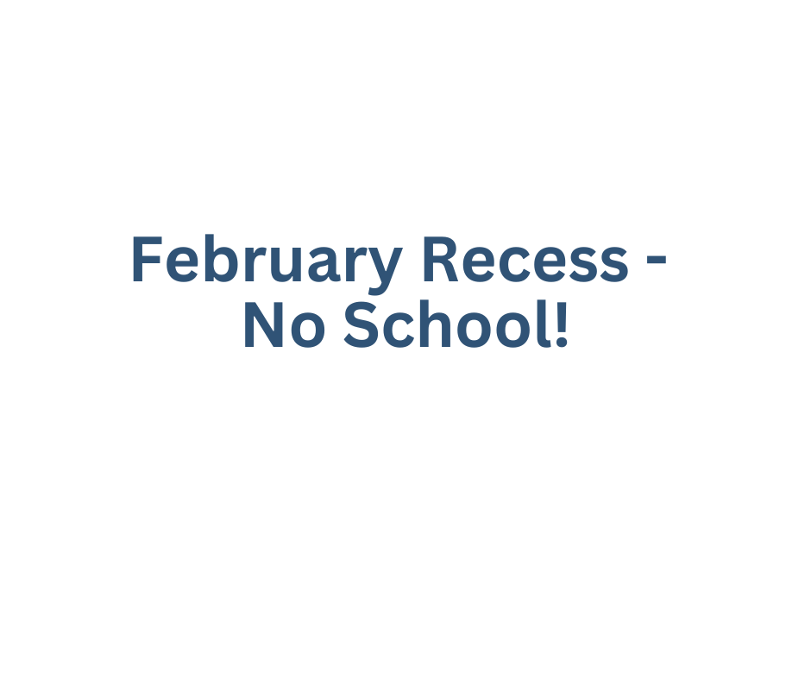­­­ 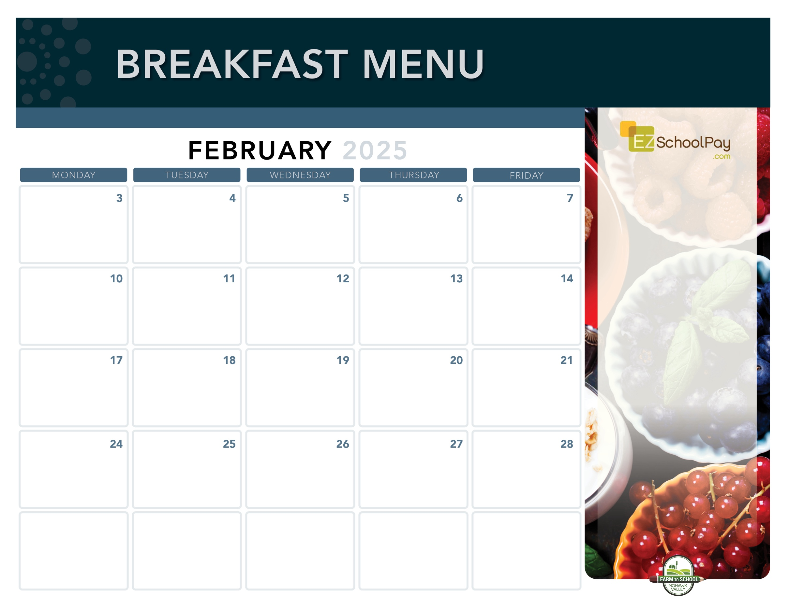

**National Pancake Day!**

Whole Grain

Pancakes

Snackin’

Waffle

Breakfast

Pizza

Scrambled Eggs

& Whole

Grain Toast

Chocolate Chip

Muffin Top

& Yogurt

**Sauquoit Valley Elementary School**

Breakfast is Free | Menu is subject to change | For more information, contact hdussault@oneida-boces.org

**Presidents Day –**

**No School**

**New!**

Assorted Whole

Grain Muffins

& Yogurt

Mini

Cinni

Breakfast

Sandwich

Whole Grain Bagel

with Cream Cheese

**Available Daily**

-Yogurt

-Assorted Whole

Grain Cereals

-Fresh Fruit

-Chilled Fruit Juice

-Ice-Cold New

York State Milk

Plain or Chocolate

OHM BOCES Food Service is an Equal Opportunity Employer.

Pancake

Sausage Stick

Cinnamon

Bun

Whole Grain Bagel

with Cream Cheese

Yogurt

Parfait

Snackin’

Waffle

Zee Zee

Bar