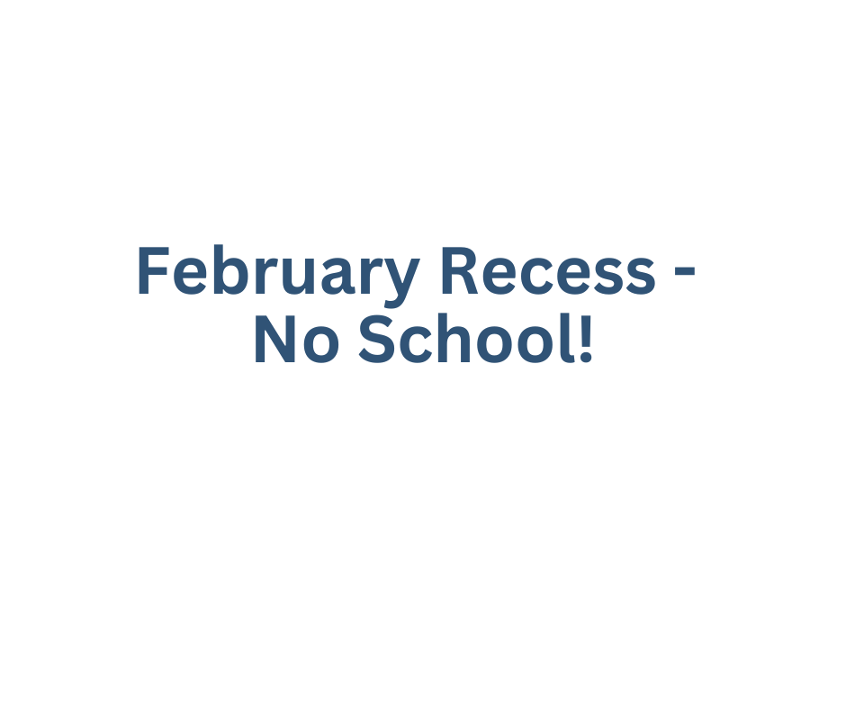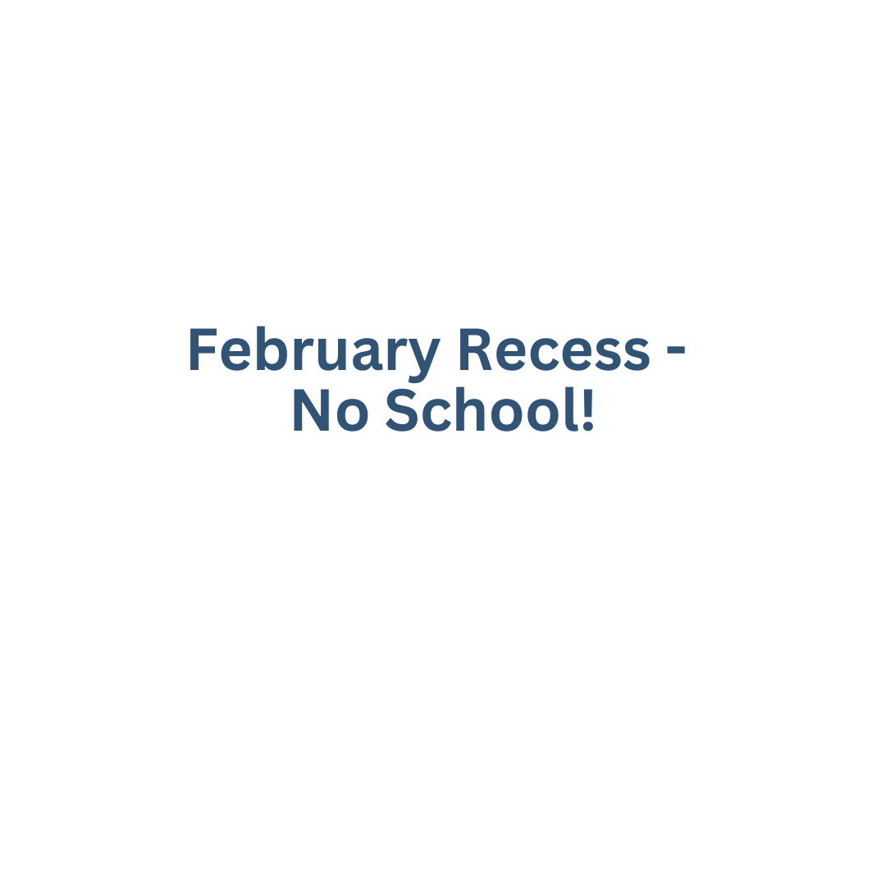­­­ 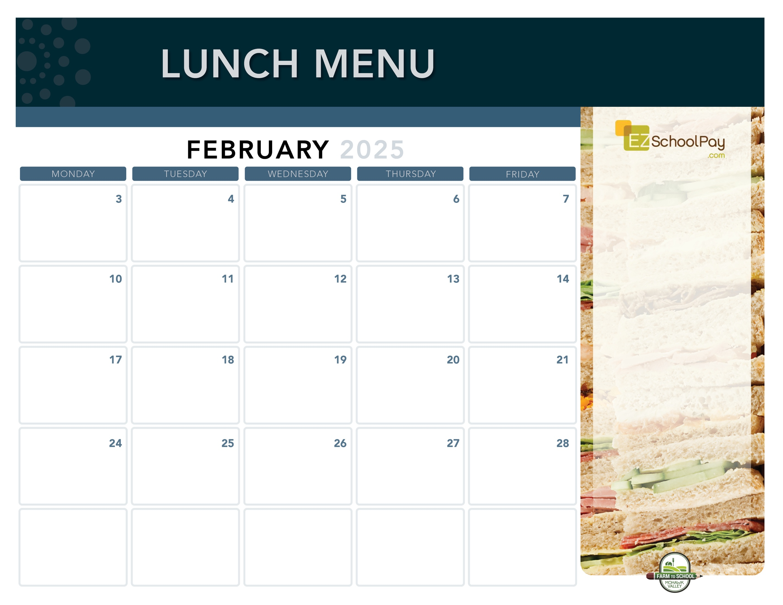

**Sauquoit Valley Elementary School**

Lunch is Free | Menu is subject to change | For more information, contact hdussault@oneida-boces.org

**Dip N’ Sip**

**Grilled Cheese Sandwich**

**& Tomato Soup**

Mixed Deli Sandwich

Carrots

**Brunch for Lunch!**

French Toast Sticks

Breakfast Sausage

Mixed Deli Sandwich

Golden Hashbrown

**Homestyle**

**Plain or Garlic Parm**

**Chicken Tenders**

Goldfish Crackers

Tuna Salad Sandwich

Broccoli

**Meatball Sub**

Mixed Deli Sandwich

Carrots

**Pizza Party!**

Cheesy Cheese or

Pepperoni Pizza

Fresh Green Salad

**Turkey Gravy**

Dinner Roll

Mixed Deli Sandwich

Whipped Potatoes

Veggie Choice

**Italian Dunkers**

**with Dipping Sauce**

Deli Ham Sandwich

Green Beans

Grape Slushie

**Chicken & Cheese Quesadilla**

Deli Turkey Sandwich

Corn

**Crispy Chicken**

**Sandwich**

Tuna Salad Sandwich

Broccoli

**Pizza Party!**

Cheesy Cheese or

Buffalo Chicken Pizza

Fresh Green Salad

**Macaroni & Cheese Plain or Buffalo Chicken**

Deli Ham Sandwich

Green Peas

**Taco Tuesday**

Beef Tacos

Lettuce, Tomato & Cheese Cup

Deli Turkey Sandwich

Street Corn Salad

**Presidents Day –**

**No School**

**Pizza Party!**

Cheesy Cheese or

Garlic Pizza

Fresh Green Salad

**Mozzarella Sticks**

**with Dipping Sauce**

Deli Ham Sandwich

Green Beans

**Chicken & Waffles**

**with Maple Syrup**

Tuna Salad Sandwich

Broccoli

**Available Daily**

Fresh Entree Salads

Party Plates

Peanut Butter & Jelly Sandwich

Fresh Sandwiches and Wraps

Assorted Fresh Fruit

Vegetable Cruncher Cups

Variety of Fresh Fruit & Juice

Ice Cold New York State Milk

Plain or Chocolate

**Local Items this Month**

Milk, Yogurt, Meatballs, Corn, Green Peas, Green Beans,

Grape Slushie,

Local items are indicated with a star on the menu



OHM BOCES Food Service is an Equal Opportunity Employer.