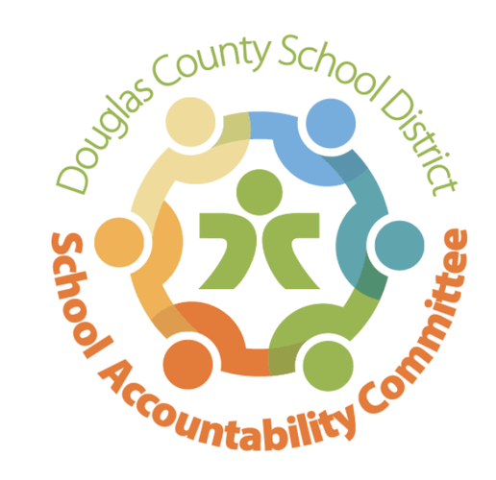2024-2025

Ranch View Middle School

School Accountability Committee (SAC)

**Agenda for meeting on:**

Date: 1/27/25

Time: 4:15-5:15

Location: RVMS Library

**Meeting Logistics:** Erin Turley (3 minutes)

* Introductions & Quorum
* Approve prior Meeting Minutes

**Celebrations & School-Wide Past Happenings:** Erin Kyllo (10 minutes)

* 2nd Semester Update
* Update on funds raised from the (caramel) Fundraiser
* Pod War monthly update
* Winter Play “The Greek Mythology Olympiaganza”
* Turkey Trot
* Winter Instrumental and Choir Concert
* RVMS Spelling Bee (1/9) ~District Spelling Bee coming up on 2/1
  + Spelling Bee winners - Logan Fogel, Cristian Torres Khotsyphom, and Jonah Klukowski, and runner up Amelia Brock
* Passport to Excellence (1/23)

**New Business:** Erin Kyllo (40 minutes)

* Updates on the upcoming 2025/2026 School Year
  + Open Enrollment Numbers: District 850/ I predict 820
  + Coffee Talk for incoming families: 2/6 @1:30
  + 6th Grade Registration Elementary School Visits
  + Pod Visits by Administration
* School-wide Happenings:
  + Parent-Teacher Conferences: February 11
  + Valentine’s Day Dance February 13 @ 5:30 pm
  + 1st Annual RVMS Career Day: February 28
  + Grizzly Gives Week: March 3-11
    - Penny Wars February 10-13
    - T-shirt sale & donation link
    - Stop the Clock
    - Dodgeball
    - Homework passes
    - Theme Days/Spirit Week
  + Spring Musical: Annie Jr. March 6-8
  + Band & Orchestra Concert: March 10
  + Last day of 3rd Quarter: March 14
  + Spring Break: March 17-21
  + CMAS Testing: April 7-18

**Standing Reports:** (20 minutes)

* Teacher Report: Craig Moody
* DAC (District Accountability Committee): Kate Thorne
* PIT Crew (Parent Teacher Organization) Report: Lyndsi
* Community Report: Jenny Parks
* Principal’s Wrap-Up: Erin Kyllo

**Open forum for guests:** Chair (5 minutes), Community Members (3 min. max)

**Next SAC Meeting: May 12th @ 4:15 in the RVMS Library**