Pitt County Schools
Title I Inventory Audit
School Name:

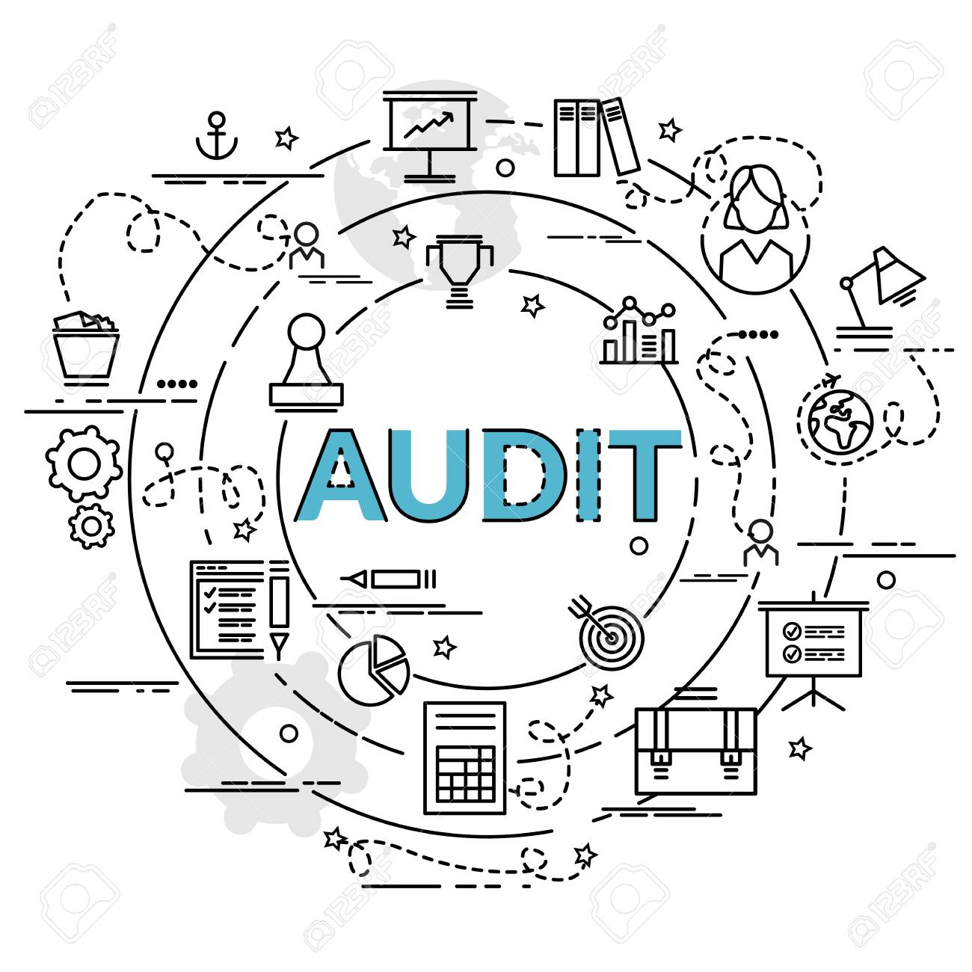

Principal Signature |  |  |  | Date
Media Coordinator |  |  |  | Date

File this documentation on your school Title I website.

