Troubleshooting ParentVUE:
ParentVUE is connected to the email address that was used when your child was registered. An email was sent providing the log-in information. If you need assistance please see Ms. Burrus, Student Data Specialist (SDS) in the main office to update your email information in Synergy. If she is unable to assist you, she can direct you to someone who can.
If you know the email address that you used when registering your child but do not have/remember the password. Click “Forgot Password” to reset it.
Step 1 - Log on to www.npsk12.com/
Step 2 – Click on For Parents/Students.
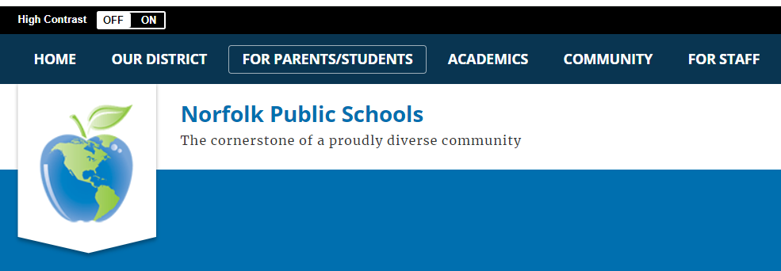
Step 3 – Scroll down to the bottom of the page and click on ParentVue.
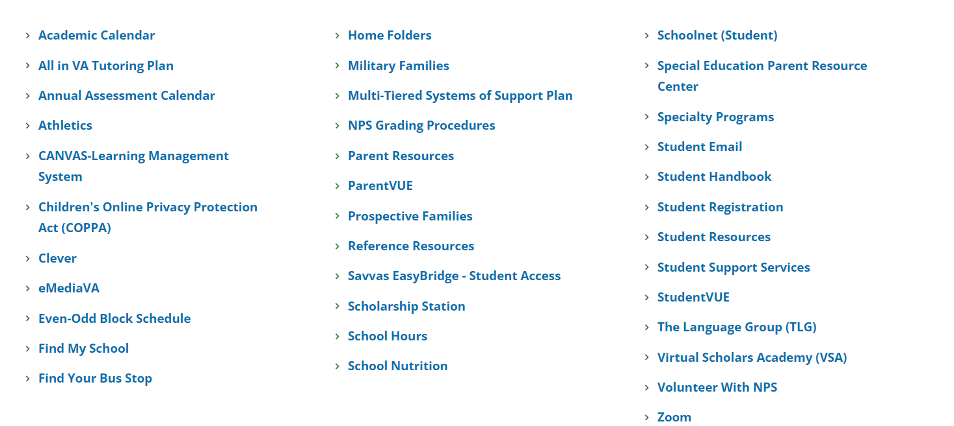

Step 4 – Click on I’m A Parent
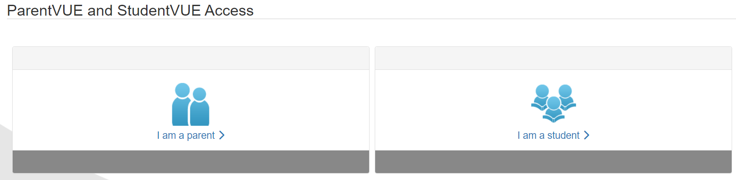

Step 5 – Sign in by using the information that was sent to you via email.
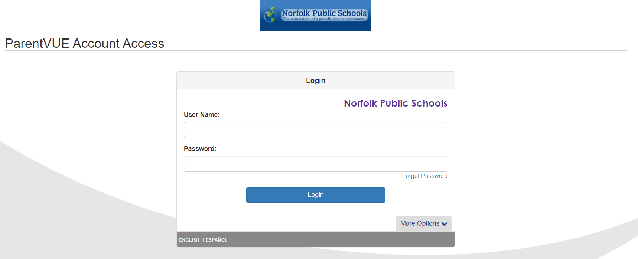
Step 6 – Go to the tool bar on the left and click on the tap you need information from. The Documents tab will lead you to assessments (district and state tests).
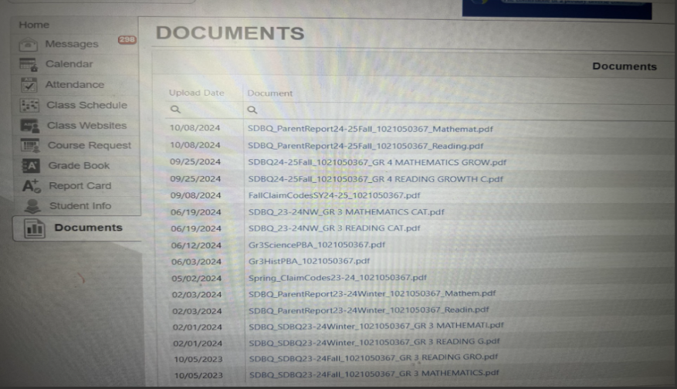
You also have access to your child’s attendance and grades through ParentVUE. Do not hesitate to contact your child’s teacher if you have questions regarding what is posted.

