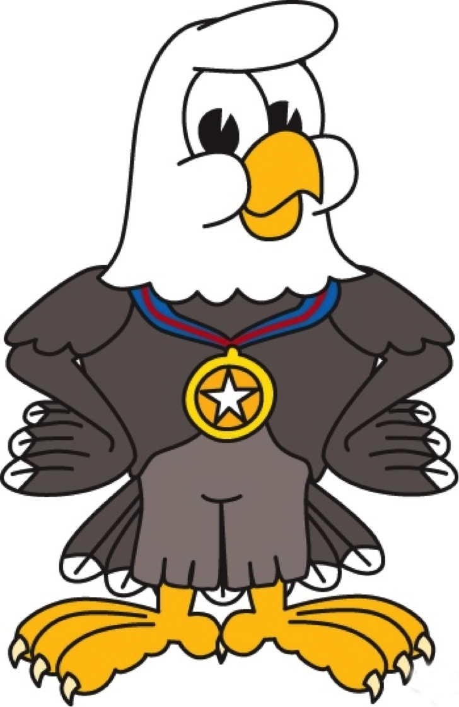
James Monroe Elementary School
Back To School Supply List

Kindergarten  - Backpack without wheels (labeled)  - 2 composition style)  - 10-12 pencils in yellow  - 4 large erasers  - 8 glue sticks  - 3 boxes of tissues  - large container disinfecting wipes  - 2 full size bottles of hand sanitizer  - 3 dry erase markers  - Ziploc bags-small and large  - Index cards  - 1 glue bottle- white  - 2 boxes of crayons (24 pack)  - 1 pair scissors | 1st Grade  - 4 Pink Pearl erasers  - 2 plastic pencil boxes  - 2 boxes of tissues  - 2 full size bottles of hand sanitizer  - 6 glue sticks  - 2 boxes of crayons (24 pack)  - 2 packages of pencils (12 pack)  - 1 pair scissors | 2nd Grade  - Dry erase markers  - 5 composition notebooks  - 2 boxes of crayons (24 pack)  - 1 pair scissors  - 4 packages of pencils (12 pack)  - 6 glue sticks  - Colored pencils  - 1 ruler- inches and centimeters (wood preferred)  - 4 large erasers  - highlighters  - 2 full size bottles of liquid hand sanitizer  - 4 boxes of tissues  - 1 container of Clorox or Lysol wipes
3rd Grade  - 1 Pencil box/pouch  - 4 packages of pencils (12 pack)  - 1 pair scissors  - 2 packs of wide-ruler paper  - 4 glue sticks  - 1 3-pack of dry erase markers  - 2 pocket folders with metal prongs  - 1 package of pink erasers  - 1 package of permanent markers  - 2 full size bottles of liquid hand sanitizer  - Water bottle (refillable) | 4th Grade  - 1 binder 1.5 inch  - Dividers  - Dry erase markers  - Sticky notes  - Ziploc bags  - 5 packages of wide ruled loose-  leaf paper  - 4 packages of #2 pencils (12 pack)  - colored pencils (24 ct)  - 6 glue sticks  - 4 boxes of tissues  - 3 ring pencil storage bag  - headphones  - 2 highlighters  - 3 packages of 3x5 index cards | 5th Grade  - Dividers  - Ziploc bags gallon (boys)  - Ziploc bags sandwich (girls)  - 2 packages of wide ruled loose- leaf paper, 150 sheets  - 5 pocket folders without prong assorted solid colors  - 4 packages of #2 yellow pencils (12 pack)  - 1 box of colored pencils, pre-sharpened (12 ct)  - Ear buds  - 1 package of washable markers- broad line, 10 basic colors  - Expo dry erase markers  - 4 glue sticks  - boxes of tissues  - Water Bottle (refillable)
Pre-K  - 2 boxes of tissues  - 2 bottles of hand soap  - 2 bottles of hand sanitizer  - 2 containers of baby wipes  - 2 rolls of paper towels  - 1 blanket for naptime (labeled)  - 1 full-set of emergency clothing  - 1 backpack without wheels (labeled)  - 2 gallon size, quart size, sandwich size and snack size boxes of Ziploc bags  - A jacket or sweater to leave at school | 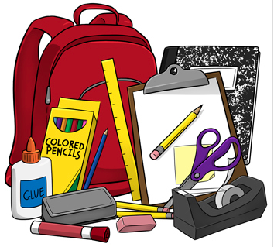  Thank you for ensuring all school supplies are purchased for your scholar. We look forward to a great year of teaching and learning! Also, please keep in mind that these supplies will not last the entire school year.

