JAMESTOWN COMMUNITY COLLEGE
State University of New York
Connect with Millions
Learn a Language
SPANISH 2510 Course Syllabus Suzanne M. Charles
Course Instructor: Suzanne M. Charles Contact Information:
Phone: 716-375-6600 ext.2127
Email: scharles@alcsnv.org
Schedule appointments: period 2, 7, period 9, and after school hours with appointments (in advance and when available)
You may contact me via the email address above or via Microsoft Teams.
Full Year Course: 2024-2025
CRN: ____

Textbook and Required Materials
You don't need to purchase a textbook for this course. I will provide you with all the materials you need.
You MUST have access to a computer or other device, a microphone, and webcam for this course. You will be required to access several different websites to support your language learning. I have listed them below in the order that they will be introduced in the course. JCC has its own learning management system, however for this course we will be using Microsoft Teams.
Yabla - uses authentic videos of native speakers to provide you with an immersive language-learning experience. There are subtitles for each video which will help you to improve your listening skills and vocabulary acquisition. The assigned videos will include tutorials that apply to the topics we are exploring, as well as, the culture. We will begin using Yabla immediately. Here are instructions for setting up your Yabla account. Once you have set it up watch this tutorial.
Talk Abroad - this is a conversation site and you will interact one-on-one with a native Spanish-speaker three times during the course. You will set up a Talk Abroad account using the following section code: (to be provided soon)
Microsoft Teams - we will use Microsoft Teams to create unit resource documents and to submit assignments. The resource documents include all the tutorials and assignments that you will complete throughout the course.
Resource Document 1 (Personal and Public Identity)
Resource Document 2 (Family and Community)
Resource Document 3 (Science and Technology)
GoVideo - Often you will be asked to make an audio or video of yourself to complete an activity. This is one tool that is easy to use for such purposes. You would need to create an account and I recommend you use it with Chrome.
Speakpipe Voice-Recorder - This tool is free and an easy way for you to make a voice recording, save it, and share it. This is another alternative for completing tasks that require you to practice speaking Spanish and share it with me.
Flip will also be available for you to use for voice recordings and submitting work.
Optional Tool:
Duolinqo - is a site that could enhance vocabulary acquisition and give you opportunities to read in Spanish and interact with others who are studying the language. Previous students have enjoyed this tool.
Assessment Focus
You will be assessed on your ability to communicate in a culturally appropriate manner at the target level. The target level in SPA 2510 is intermediate-low. This graphic will help you to understand the proficiency levels and skills associated with each level.
Throughout the course, you will complete activities and assessments which develop your intercultural communicative skills. For interpersonal and presentational communication, you will be assessed using this rubric.
There are three communication modes which are assessed throughout the course:
Interpersonal Communication: students interact and negotiate meaning in spoken and written conversations to share information, reactions, feelings, and opinions. (Paired activities, formative and summative assessments, Flip, Talk Abroad)
Interpretive Communication: students understand and interpret what is heard, read, or viewed. (Formative and summative assessments, Yabla, readings, audio and video recordings)
Presentational Communication: students present information, ideas, and viewpoints.
(Formative and summative assessments)
Additionally, there are two intercultural communication standards which will be assessed:
Cultural Investigation: investigating products and practices to understand cultural perspectives. (Culture Project)
Cultural Interaction: interacting with others in and from another culture. (Talk Abroad)

Grade Calculation
Your final grade will be calculated as follows: Language Proficiency:
Intercultural Theme 1 Assessment (Personal and Public Identity): | (12%)
Intercultural Theme 2 Assessment (Family and Community) | (12%)
Intercultural Theme 3 Assessment (Science and Technology) | (12%)
*Please note PowerSchool does not allow for me to change the themes for credit, thus the theme will read on PowerSchool as theme 1 even though we may be in theme 2 or 3. This is solely for grading purposes.
Intercultural Proficiency:
Cultural Investigation (Culture Project) (10%)
Cultural Interaction (Talk Abroad conversations, Flips, and Reflections) (15%)
Formative activities: (39%)
Resource Documents
Assignments
Yabla
Formative assessments
Participation which encompasses attendance at instructor/student meetings and partner conversations
There will be a final assessment at the end of this course which will figure into the fourth quarter.
Note 1: Extra credit options will be offered sparingly and only to the entire class. Note 2: You must contact me in advance via phone or email if you are going to miss a unit assessment deadline. You must provide an explanation, which is deemed acceptable and coordinate an alternate due date. If you don't notify me in advance and receive approval, you will not be able to take the assessment.
Grade | Percentage | Meaning | Quality Points
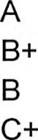
90 - 100 Excellent 4.0
86 - 89 Very good 3.5
80 - 85 Good 3.0
76 - 79 Above Average 2.5
C 70 - 75 Average 2.0
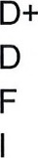
66 - 69 Fair 1.5
65 Passing 1.0
0-64 Failing 0.0
Incomplete 0.0
TThe proficiency target for SPA 2510 is intermediate-low.

Work submitted late without notifying me in advance will not be accepted. Authorized late assignments are reduced 10% per day and will only be accepted for 4 days. It is imperative that you keep up with the work and do it gradually. It will be very difficult to catch up once you fall behind.
Attendance Policy: It is imperative to be an active participant. You will need to work with a classmate to practice speaking during the semester. In order for this to be successful, everyone must be flexible and responsible. This is especially important during these unprecedented times.
Syllabus/Course Outline Changes: If there are any changes to the information provided in this syllabus or the course outline I will update this on my school webpage. The syllabus online will always be the most up to date document.
Emergency Closing Procedures: Please refer to the closing information for Allegany-Limestone MHS
Expectations and Responsibilities of Students
What constitutes cheating in Spanish class? Examples are plagiarism, writing an assignment in English and then translating it into Spanish with a Spanish translator, copying another student's work online or in class, having another student/person do your work for you, and copying all or part of information found on the web or in another resource without citing your source. https://www.sunyjcc.edu/student-life/student-responsibilities/academic-integrity
What can you expect from this class?
- To receive tons of input in Spanish by reading, listening, and watching.
- To speak Spanish with your classmates, teacher, and native Spanish-speakers.
- To learn more than Spanish. That's right! You will learn new technology, about cultures all over the world, and perspectives that are different than your own.
- To be challenged! Learning a language requires determination, diligence, and an open mind. It also requires you to continue pushing yourself and work hard.
- To meet people from all over the Spanish-speaking world.
- To feel uncomfortable at times, but that is okay. We are always uncomfortable when we are learning a new skill.
What you won't encounter in this class?
1. Long grammar lessons
- Lectures
- Worksheets that simply require you to fill in a blank
- Lots of English
- The teacher giving you the answer.
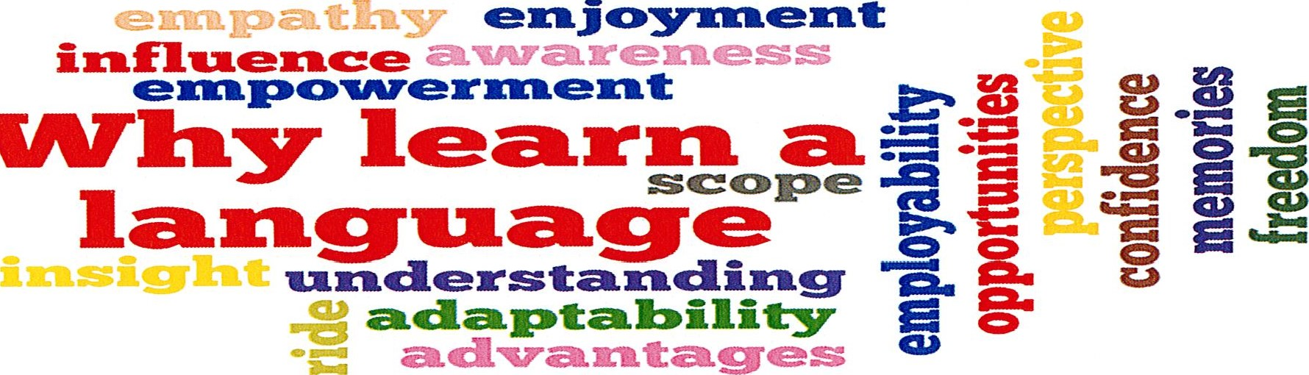
Why

