_______________’s
Primary Source in 21st Century History

The Coronavirus Pandemic of 2020
By:
_______________________________

________________________________________________________________________________________________________________________________________________________________________________________________________________________________________________________________________________________________________________________

First Fact I Learned About CVOID-19… ___________________________________________________________________________________________________________________________________________________________________________________________________

How I felt, when I heard the news…

Did you think it was real?
YES/NO
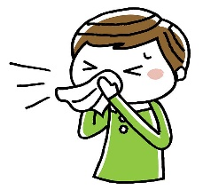

What was the craziest response you heard people have to the news?
___________________________________________________________________________________________________________________________________________________________

Did you respond with fear? Why? ____________________________________________________________________________________________________________________________________________________________
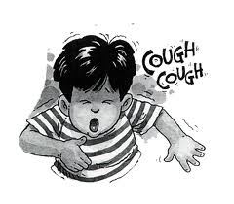

Did your family rush out to buy toilet paper? Did they find any?
______________________________________________________________________________

What did they do? ____________________________________________________________________________________________________________________________________________________________
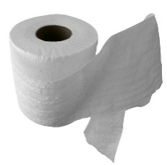

What else did your family struggle to find? ____________________________________________________________________________________________________________________________________________________________
Who was the US President? _____________________________________
He was the __________ US President.
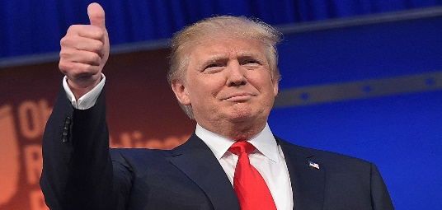

What did you hear him say, during all of this? ____________________________________________________________________________________________________________________________________________________________________________________________________________________________________________________________________________________________________________________________________________________________________________________________________________________________________________________________________________________
Where did you go to school? _______________________________________
What did they do about keeping students healthy? ____________________________________________________________________________________________________________________________________________________________ Was your school helpful in helping you learn, while you were home? Why/Why not? ___________________________________________________________________________________________________________________________________________________________________________________________________
Did they deliver your family food?
Yes/No
If so…How did you get it? _______________________________________
What were the healthy practices that were established and communicated to keep people virus-free, during this pandemic?
Step 1: | Step 2:
Step 3: | Step 4:
Step 5: | Other:
Funny Facts You Heard/Read…

- ____________________________________________________________________

- ____________________________________________________________________

- ____________________________________________________________________

- ____________________________________________________________________

- ____________________________________________________________________

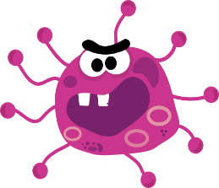

What’s Popular in 2020? ___________________________________________________________________________________________________________________________________________________________________________________________________
What’s good music in 2020? ___________________________________________________________________________________________________________________________________________________________________________________________________
What’s for dinner in 2020? ___________________________________________________________________________________________________________________________________________________________________________________________________
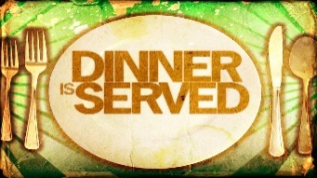

What sports were you playing? ____________________________________________________________________________________________________________________________________________________________

(attach a sports pic of you or someone you know here)

What got cancelled that you missed out on? ____________________________________________________________________________________________________________________________________________________________
How did you feel? ______________________________________________________________________________

(attach artifact of cancelled event(s) here)

How much did 2020 cost?


This Photo by Unknown Author is licensed under CC BY-NC-ND

Milk _______________________________
Bread _____________________________
Butter_____________________________
Cheese_____________________________
Chocolate Candybar______________
Gasoline___________________________
Oil Change_________________________
Rent________________________________ Mortgage___________________________
Daycare____________________________
Private School_____________________
College_____________________________
Car_________________________________

What did your family do, during the country-wide QUARANTINE? _____________________________________________________________________________________________________________________________________________________________________________________________________________________________________________________________________________________________________________________________________________________________________________________________________________________________________________________________________________________________________________________________________________________________________________________________________________________________________________________________________________________________________________________________________________________________________
Draw a picture of it…

What was your favorite memory you made? ____________________________________________________________________________________________________________________________________________________________

What was your favorite game you played, as a family? ______________________________________________________________________________

What new game did you learn how to play? _______________________________________
Describe it… ___________________________________________________________________________________________________________________________________________________________________________________________________
What new thing did you learn, during this time? ____________________________________________________________________________________________________________________________________________________________
Draw a picture (or include photo) of your family participating in a family activity.

(continued)

If you could have changed one thing, about this time in history, what would it be? ___________________________________________________________________________________________________________________________________________________________________________________________________
What was the most exciting thing? ___________________________________________________________________________________________________________________________________________________________________________________________________
What was the scariest thing? ___________________________________________________________________________________________________________________________________________________________________________________________________
If you could have been the President of the United States, during this time, what would you have done differently? _______________________________________________________________________________________________________________________________________________________________________________________________________________________________________________________________________________________________________________________________________________________________

(Attach 2020 Photo of You Here)

What else was happening in history, current events, during the CVOID-19 Scare?
_____________________________________________________________________________________________________________________

_____________________________________________________________________________________________________________________

_____________________________________________________________________________________________________________________

_____________________________________________________________________________________________________________________

(Attach Artifacts or Newspaper Clippings Here)

(Attach Artifacts or Newspaper Clippings Here)

(Attach Artifacts or Newspaper Clippings Here)

(Attach Artifacts or Newspaper Clippings Here)

(Attach Artifacts or Newspaper Clippings Here)

What was happening in sports, during this time? _____________________________________________________________________________________________________________________

_____________________________________________________________________________________________________________________

_____________________________________________________________________________________________________________________

_____________________________________________________________________________________________________________________

(Attach Sports Articles Here)

(Attach Sports Articles Here)

(Attach Sports Articles Here)

__________________________ Family

2020 Family Photo

